Study on expected changes in costs of labour force and construction materials in the construction sector in Latvia

REPORT

Rīga, 2019

Study on expected changes in costs of labour force
and construction materials in the construction sector in Latvia

The study was carried out for the period from 1 January 2019 to 31 December 2020 and provides an evaluation of trends for the period from 1 January 2021 to 31 December 2023 for changes in total volumes of construction products and costs and for subsectors of the construction sector.

 | Contractor:  SIA “Oxford Research Baltics”  Kr. Valdemāra iela 23-37 k.2, Riga, LV-1010 |  | Contracting Authority:  Ministry of Economics of the Republic of Latvia  Brīvības iela 55, Riga,  LV-1519

Table of contents
Table of contents 2
ABBREVIATIONS USED 3
OVERVIEW 4
1. INTRODUCTION 6
2. GENERAL FORECASTS OF CHANGES IN THE VOLUME AND COSTS OF CONSTRUCTION PRODUCTS 9
2.1. Forecasts of changes in the total volume of construction products 9
2.2. Forecasts of changes in the total construction costs 11
3. FORECASTS OF CHANGES IN COSTS OF CONSTRUCTION RESOURCES 17
3.1. Factors affecting changes in costs of labour force and construction materials 17
3.2. Summary of changes in costs of construction resources for forecasts 23
4. FORECASTS OF CHANGES IN THE VOLUME AND COSTS OF CONSTRUCTION PRODUCTS AND COSTS OF RESOURCES BY CONSTRUCTION SUBSECTORS 24
4.1. Forecasts of changes in costs of the subsector Construction of residential and non-residential buildings 24
4.2. Forecasts of changes in costs of the subsector Construction of transport objects 31
4.3. Forecasts of changes in costs of the subsector of construction of main underground pipelines 35
4.4. Forecasts of changes in costs of the subsector of other civil engineering projects 39
4.5. Forecasts of changes in costs of the subsector construction of complex structures in industrial manufacturing companies 42
4.6. Summary of forecasts of changes in costs by subsectors 45
MAIN RESULTS 47
CONCLUSIONS 49
ANNEXES 51

ABBREVIATIONS USED

Abbreviation | Explanation
CAGR | Compound annual growth rate
CFCA | Central Finance and Contracting Agency
CSB | Central Statistical Bureau
Subsector Construction of residential and non-residential buildings | This group includes full-cycle construction of residential and non-residential buildings, as well as for compensation or on the basis of a contract. Part of construction works or even the entire scope of construction works may be fulfilled by subcontractors
MoE | Ministry of Economics of the Republic of Latvia
EU | European Union
Eurostat | Statistical office of the European Commission
MoF | Ministry of Finance of the Republic of Latvia
GDP | Gross domestic product
Contractor | SIA “Oxford Research Baltics”
Subsector Construction of complex structures in manufacturing companies | Structures having no signs of buildings – structures of mining industry or rock mining, power plants, chemical industry companies
Contracting Authority | Ministry of Economics of the Republic of Latvia
Subsector Construction of other civil engineering projects | Construction of waterways, ports and river berths, locks, dikes and dams; dredging of waterways. Construction of complex industrial (manufacturing, chemical plants) buildings, except construction of buildings, structures, open air sport grounds. Division of land into plots with improvement of land
Profit margin | Profit margin is viewed in this study as profit after tax as a percentage of turnover.
Study | Final deliverable, report “Study on expected changes in costs of labour force and construction materials in the construction sector in Latvia”
Subsector Construction of utility projects | Construction of distribution lines for transportation of liquids and related buildings and objects, which are components of these systems (main and city pipelines; construction of water pipelines and water lines; irrigation systems; reservoirs; waste treatment plants; pump stations, drilling of water wells). Construction of electricity transmission and communication distribution lines and related buildings and objects (for example, power plants), which are components of these systems.
Subsector Construction of transport objects | Construction of motorways, streets, roads, other roads; runways of airfields. Construction of railway and subway tracks. Construction of bridges, including connecting bridges and overpasses on land motorways, construction of tunnels
CIT | Corporate income tax
SRS | State Revenue Service

OVERVIEW
The “Study on expected changes in costs of labour force and construction materials in the construction sector in Latvia” was prepared in accordance with the agreement concluded between the Ministry of Economics of the Republic of Latvia and the research company SIA “Oxford Research Baltics” on 14 May 2019.
A study on expected changes in costs of labour force and construction materials in the construction sector was carried out in accordance with the task given in Paragraph 7 of §1 of protocol No.41 of the meeting of the Cabinet of Ministers of 28 August 2017 to be able to plan potential costs of public construction procurements more effectively and evaluate potential changes in prices in the nearest years.
The study was carried out on the basis of the study of 2018 on expected changes in the costs of labour force and construction materials in the construction sector in Latvia and drafted methodology (hereinafter referred to as the Methodology) to ensure equal approach and comparability of obtained results.
The study was carried out for the period from 1 January 2019 to 31 December 2020 and provides an evaluation of trends for the period from 1 January 2021 to 31 December 2023.
The study includes a detailed evaluation and forecasts for the period from 2021 to 2023 on changes in total volumes of construction products and changes in costs and for the following subsectors of the construction industry – residential buildings, non-residential buildings, other civil engineering structures, transport objects, underground main pipelines, construction of complex structures in industrial manufacturing companies and construction of other civil engineering projects.
An evaluation and analysis of factors affecting changes in costs of labour force and construction materials, as well as the potential effect of shadow economy combating measures were implemented during the study.
The study has taken into consideration the effect of the introduced and planned shadow economy combating measures on the construction industry.
Statistical methods, expert interviews and combination of research methods were used to achieve the study results, in accordance with the Methodology. Statistical data form the data array of the study. Expert interviews identified the factors affecting changes in construction costs, their impact level, expert evaluations of trends in price changes. Time series with their up-to-date development were retrieved for the identified factors.
CSB data and expert interviews with representatives of the construction industry and experts in subsectors of the construction industry were used in the study as sources of information. The study also includes forecasts of experts in macroeconomics for the evaluation of impact of general factors. No less than four experts were involved in each group of experts. Expert groups were set up and selected at several stages identifying company by their main area of business in the construction industry, their region of operations, the turnover range and the competence level.
Different analytical methods, according to the studied task, data development trends and the expert evaluation scale were used for the analysis of statistical data and expert evaluations obtained during the study. Different types of models characterising further development of basic trends of time series on the basis of previous trend extrapolation were used to determine further development of changes in costs. The quality of obtained models was evaluated with dispersion indicators.
Calculations of cumulative average, structural average and dispersion indicators were used in processing of the expert evaluations obtained in interviews depending on the form of questions and the scale used. In addition to the separate analysis of statistical information and expert evaluations, combined forecasts, which included different types of forecasting used in the study, were used as the final forecast tool, which was done for the purposes of compensation for errors and improvement of the credibility of the final forecast and data.
Main conclusions:
1. The forecasts provide that the total volume of construction products will increase by more than 10% in 2019 and 2020 compared to the previous year, and a drop in the increase and a drop in volumes is expected after 2021.
2. The increase in total volumes of construction products will directly affect changes in costs, which will increase by about 5% in 2019 and 2020 compared to the previous year, and might even reduce in 2022.
3. The forecasts provide that wages of workers will increase the most among all types of resources and may reach a cumulative increase of 20% in 2023 compared to the level of 2018, but changes in costs of architectural and engineering activities and technical testing and analysis – a 15% increase. Changes in costs of construction materials and maintenance and operation machines and mechanisms will reach a cumulative increase of 6-7% in 2020 compared to the level of 2018 and will almost remain unchanged.
4. The subsectors, where the forecasts expect to have the highest increase in changes in costs are buildings and complex structures, where a more rapid increase in 2019 and 2020 will be replaced by a slower increase. The second group includes transport objects, underground main pipelines and construction of other civil engineering projects, whether an increase in 2019 and 2020 will be followed by a decline or fluctuation around the zero level of changes in costs.
5. Volumes of construction products are the main factor affecting changes in labour force and construction costs in Latvia.
6. The scope of public procurement in construction has significant effect on the construction sector due to its share. The risk of significant drop of the scope of public procurement in construction is forecast after 2020, if the volume dynamics is similar to the previous EU funds programming period after 2014, and the drop in the volume of project co-financed by EU funds is not replaced with state, local government, private sector projects and projects started in the new EU funds programming period in a timely manner.
7. Total volumes of construction products will depend on market elasticity adapting to the deferred private demand in 2018-2020.
8. Forecasts of changes in costs evidence that the level of construction costs is expected to remain practically unchanged also after 2020, similarly to 2014-2016. Therefore there is a significant risk that private demand will not immediately replace the drop in public procurement and a significant drop in construction volumes is possible.
9. It is recommended to use public order as a tool for balance of market fluctuations.
10. The implementation of shadow economy combating measures increases changes in costs of construction materials and labour force. However, this effect is much more pronounced in terms of the effect on changes in labour costs, it is most affected by two shadow economy combating measures: the full implementation of the electronic system for registration of working hours, incl. transfer of data to SRS, and determination of the minimum wage level in the construction sector, using the general agreement. Unlike for the effect of shadow economy combating measures on changes in costs of labour force, some specific evidently the most important factor cannot be determined for changes in costs of construction materials due to similar average values in evaluations.
11. If we compare the forecasts of the study for 2019 with the study for 2018, the forecasts of increase in volumes of construction products have become considerably more cautious in the context of the entire period of the forecasts, and the increase in construction costs is therefore forecast at a lower level – the five-year annual average forecast for an increase in construction costs reduced from 4.3% to 2.1%.

The study cannot be duplicated, transferred, rewritten, stored in an electronic search system or translated into another language without a prior consent from MoE.
It is not allowed to transform the content of the information included in the document. The information included in the document may be quoted providing a reference to the original document.

INTRODUCTION
The study on expected changes in costs of labour force and construction materials in the construction sector in Latvia was carried out for the period from 1 January 2019 to 31 December 2020 and provides an evaluation of trends for the period from 1 January 2021 to 31 December 2023. This is the second study of such type and it is based on the methodology drafted for the study for 2018. Study of 2018 on expected changes in costs of labour force and construction materials in the construction sector in Latvia in the period from 2018 to 2022.
The study includes a detailed evaluation and forecasts on changes in total volumes of construction products and changes in costs and separately for the following subsectors of the construction industry – residential buildings, non-residential buildings, transport objects, underground main pipelines, complex structures in industrial manufacturing companies and construction of other civil engineering projects. And also a detailed evaluation and forecasts of types of resources: changes in costs of construction materials, wages of workers, changes in costs of maintenance and operation of machines and mechanisms, and designing (architecture, construction engineers, etc.). An evaluation and analysis of factors affecting changes in costs of labour force and construction materials, incl. the effect of shadow economy combating measures were also implemented during the study.
CSB data and expert interviews with representatives of the construction industry and experts in subsectors of the construction industry were used as sources of information in the study. Forecasts of experts in macroeconomics were also included in the study for the evaluation of impact of general factors. The statistical trend analysis, expert interviews and combination of methods (see Figure No. 1) were also used as data acquisition methods in the study.
Figure No. 1. Data acquisition methods used and their sequence

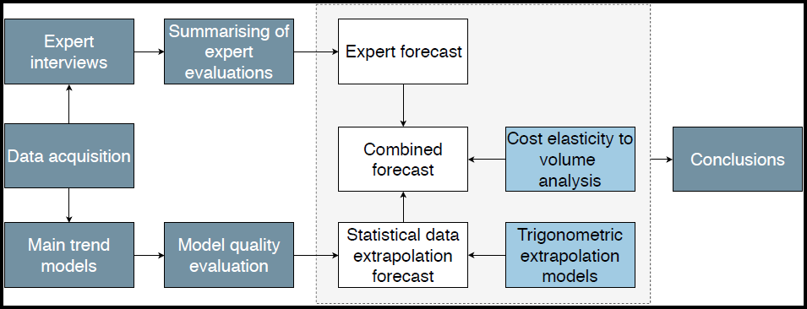
Source: created by the authors

At the beginning of the report forecasts of changes in total costs across the sector are analysed and described paying special attention to the factors influencing changes in costs of labour force and construction materials, forecasts of changes in the volume and costs of construction products, as well as the impact of the volume of construction products on changes in costs and the industry average profit margin. Further analysis is broken down by construction subsectors and types of resources.
The obtained results show accurate values of forecast changes in construction costs, however the interpretation of results should take into account that the obtained results are more likely an indication of general trends and may change in practice depending on actual progress of large construction projects, market response to changes in construction volume and a number of other factors, which cannot be forecast accurately.

GENERAL FORECASTS OF CHANGES IN THE VOLUME AND COSTS OF CONSTRUCTION PRODUCTS

Forecasts of changes in the total volume of construction products
In accordance with the results of analysis of the factors affecting changes in costs and statistical data, changes in construction costs are largely affected by the demand for the volume of construction products and the sold volume/supply, to which market prices respond, therefore, it is important to identify potential trends and fluctuations in volume. The drop in volumes of construction products in 2016 (-16.60% compared to the previous year) was followed by a rapid increase in 2017 (18.71% compared to the previous year) and in 2018 (21.82% compared to the previous year). The main reason of the increase was an increase in the volume of EU funds construction projects.
Summary of industry expert evaluations show that an increase in volumes of construction products is expected in 2019 – 2021 cumulatively reaching 38% compared to the level of 2018. Rather significant differences in evaluations of different experts are observed, however, the average evaluation shows that the volume of construction products will remain almost unchanged after 2021 (see Figure No.2).
Figure No. 2. Changes in volumes of construction products before 2018 and forecasts from 2019 to 2023, cumulative changes compared to 2018, %
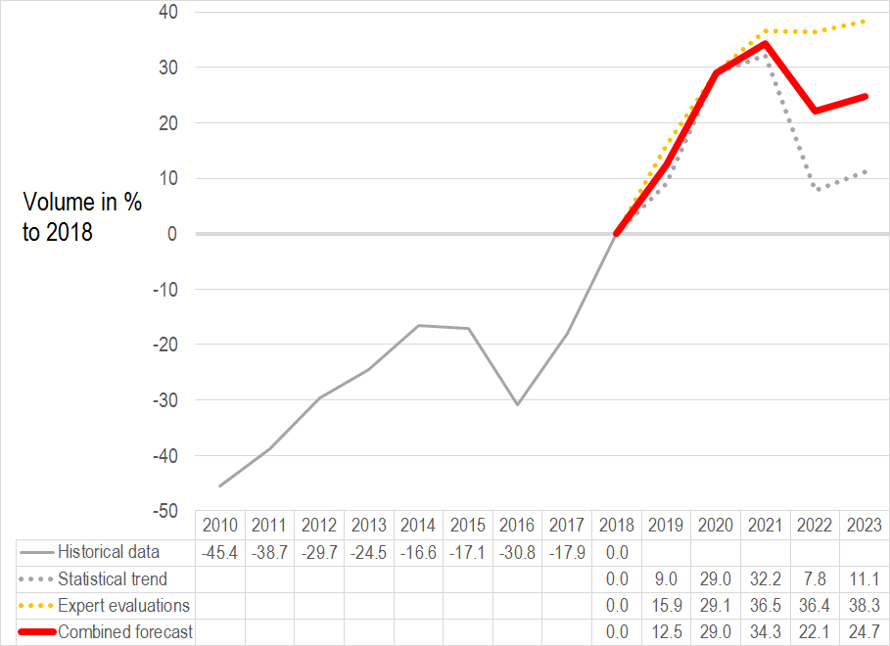
Source: CSB historical data before 2018 (inclusive) and calculations made by authors, based on expert evaluations and results of the drafted statistical trend – forecast for 2019-2023
The statistical trend, which is based on a cyclic behaviour model, since 2010, therefore without taking into account the economic crisis decline effect, shows that a decline in volume similar to that expected in 2016 is possible in 2022. However, the total volume of construction products within the scope of this model event in the lowest point would be 7.8% of the volume of 2018 in 2022.
When comparing both data sources of forecasts, it can be concluded that the vision of experts is more optimistic and this may be related to the real understanding of the demand, however, the experience of rapid increase of recent years may have caused exaggerated optimism. The statistical model indicates the risk of a drop, which would occur, if, as the volume of public construction procurement shrinks, the market is not sufficiently flexible to respond with a drop in prices, and thus private demand would not replace public demand, as well as to a situation, when in the first years of a EU funds programming period construction projects are not yet implemented in practice on a significant scale.
Therefore, the approach defined in the methodology to take into account data from both sources is considered justified, and the combined forecast form as an arithmetic mean value of data from both sources shows an increase in each year within the forecast period except 2022 (see Table No. 1).
Table No. 1. Combined forecast – changes in the volume of construction products compared to the previous year, %
Year | 2019 | 2020 | 2021 | 2022 | 2023
Changes in the volume of construction products compared to the previous year, % | 12.5 | 14.8 | 4.1 | -9.2 | 2.2
Source: calculations of the authors based on expert evaluations and results of the drafted statistical data trend
The interpretation of result should take into account also several specific factors:
- large public procurements like Rail Baltica and so on have a big effect, and their implementation, postponement and delay may have a significant impact on volumes of construction projects;
- in accordance with expert evaluations the trend that part of public order plans are postponed for the next year is observed.
- market contains contradictory information on the extent of postponement of private investments to a later time, because public demand has quickly grown since 2018;
- the model does not include projects supported by EU funds in the new planning period after 2020, however the experience of the previous EU funds programming period shows that no significant construction projects would be expected until 2023. On the other hand, indications about plans for a more timely EU funds absorption process in the next programming period are observed from the MoF.
Taking into account the risks related to the scope of projects co-financed by EU funds and the expected drop at the end of the forecast period, it is very important whether the dynamics of state and local government budget orders is adapted to the situation, planning the largest works in this period of drop in the volume of construction products.

Forecasts of changes in the total construction costs
    - Elasticity of changes in costs depending on the scope of the volume of construction products
Elasticity of changes in average costs to changes in volume was calculated within the scope of the study, which further allowed to forecast changes in costs taking into account forecasts of changes in volume. Average elasticity is calculated using:
- elasticity of changes in costs to changes in production volumes, which was obtained when interviewing experts in the first and second round of interviews;
- elasticity of changes in costs to changes in production volumes, which was obtained from historical volume of construction products and data on changes in costs;
- elasticity of changes in costs to changes in production volumes, which was obtained from historical volume of construction products and data on changes in costs, except values of 2006 – 2009.
Industry experts were asked how they forecast changes in costs depending on changes in volume in five different intervals (see Table No.2).

Table No. 2. Results of expert interviews – changes in costs depending on changes in volume, %
Level of changes in volume | -20% to -10% | -10% to 0% | 0% to +10% | +10% to +20% | +20% to +30%
Average evaluation | -3.1% | -0.8% | 4.5% | 8.8% | 12.6%
Standard deviation | 7.5% | 4.7% | 7.1% | 7.3% | 8.1%
Standard error | 1.3% | 0.8% | 1.3% | 1.3% | 1.4%
Source: calculations of the authors based on interview results
Historical elasticity indicators from data, from which the “construction boom” of 2006 – 2009 was removed, showed an effect smaller by half on an increase in changes in costs, when the volume of construction products increases, than from the entire data series since 2004. Furthermore, expert evaluations showed a higher impact. For the needs of forecasting, the formula consisting of the mean arithmetic of all the three models with elasticity coefficient 0.2594 – the combined forecast for the volume of construction products in each section of cost forecasts was included in the following formula:
I=0,2594 x A + 0,0183, where
I – changes in forecast costs compared to the previous year within the elasticity model, %;
A – combined forecast for changes in the volume of construction products compared to the previous year, %.
The resulting forecasts of changes in costs were the ones, which would form, taking into account only the causal relationship between changes in costs, depending on changes in the volume of construction products. This was used as one of three sources to create a combined forecast of costs.
When interpreting these results, it is important to take into account that in practice there is a known response time between changes in volume and changes in costs. Having statistically checked dependence of costs on volume of construction products in the previous rather than the current year no higher correlation was identified, therefore this model takes into account the volume of construction products in the year being analysed.
In order to check the importance of the impact of profit margin, elasticity of the profit margin depending on the volume of construction products is evaluated in the same way. The elasticity coefficient matches both in evaluation of experts and historical data, except values of 2006 – 2009, – 0.19. The level, however, is different – the profit margin assumed by the expert evaluation is by 3 percentage points higher.
The results show that in case of 20% increase in the volume of construction products historical data show about 4% profit margin, while expert evaluations – about 7%. This is explained by the fact that experts were asked about a profit margin acceptable for them rather than actual depending on changes in construction volume. Taking into account that it is the primary task of companies to gain profit, such rather optimistic expert evaluations compared to actual data are understandable. Both values are considered proportionate and it is assumed that prices and costs do not inadequately change even in case of a rapid increase in the volume of construction products. However, it should be taken into account that this analysis does not differentiate the solution practically used by companies to reduce profit at the expense of an increase of changes in costs to reduce the amount of CIT to be paid. Amendments to the law are expected to be made in 2019 promoting an investment of company profit in development, which might change elasticity indicators of profit margin in the future, however the impact of these improvements can be evaluated only in several years.
Table No. 3. Results of industry expert interviews – changes in profit margin depending on changes in volume, %
Level of changes in volume | -20% to -10% | -10% to 0% | 0% to +10% | +10% to +20% | +20% to +30%
Average evaluation | 0.9% | 2.1% | 4.6% | 6.1% | 8.5%
Standard deviation | 6.6% | 5.2% | 3.0% | 2.9% | 4.7%
Standard error | 1.2% | 0.9% | 0.5% | 0.5% | 0.8%
Source: calculations of the authors based on interview results

Table No.4. Results of expert interviews – acceptable profit margin in subsectors depending on changes in volume, %
Level of changes in volume | -20% to -10% | -10% to 0% | 0% to +10% | +10% to +20% | +20% to +30%
Construction of residential buildings | 6.25 | 6.63 | 7.13 | 7.75 | 10.67
Construction of non-residential buildings | 6.13 | 6.50 | 7.13 | 7.75 | 10.67
Construction of transport objects | 4.33 | 3.67 | 5.33 | 7.67 | 8.33
Construction of city infrastructure objects | 1.00 | 2.67 | 5.67 | 7.00 | 8.00
Construction of other civil engineering projects | -1.00 | -1.67 | 3.33 | 4.00 | 5.67
Construction of complex structures in manufacturing companies | 1.00 | 1.00 | 6.00 | 7.00 | 7.00
Source: calculations of the authors based on interview results
The experts were also asked about an acceptable profit margin in their subsector (see Table No.4). Overall, it is evaluated that an acceptable profit margin in building and transport subsectors is higher, in particular in case of reduction of volumes of construction products. A negative acceptable profit margin in case of reduction of volume is indicated only in subsector Construction of other civil engineering projects.
2.2.2. Statistical trend
Historical indicators of changes in construction costs were analysed with different statistical trend methods. The models used in the study for 2018 were initially verified. More accurate models, which include short-term fluctuations were used, considering the need for more credible short-term forecasts. A trigonometric model perfectly matching the historical wave trend was found iteratively. Thus, the correlation coefficient of the model has improved from 43% to 93%.
The justification of selection of the model are historical cyclic fluctuations of changes in construction costs, which, according to the analysis of historical data, was largely affected by the link of public construction order to the cycle of EU funds programming period.
2.2.3. Expert evaluations
Ten general construction experts were asked in the interviews to forecast changes in costs of construction materials. The experts have studied the dynamics of statistical data in the previous years. The average expert evaluation shows that an increase of changes in costs of construction materials is expected in the nearest years: by 4.6% in 2019, by 3.9% in 2020 and by 2.1% in 2021. After that, the forecasts for 2022 and 2023 show a smaller increase of 0.6% and 0.7%, respectively. However, evaluations of individual experts differ rather seriously and the standard error evidences that if the group of experts is increased, average evaluations might fluctuate within a percent.
2.2.4. Summary of forecasts of changes in construction costs
In connection with the increase in the volume of construction products in 2017 and 2018 an increase in changes in construction costs was observed as well (see Figure No. 3). Forecasts of changes in costs demonstrate a trend that the annual increase will become slower compared to the previous year, and changes in costs will slightly reduce in 2022.
Figure No. 3. Changes in construction costs before 2018 and forecasts from 2019 to 2023, cumulative changes compared to 2018, %
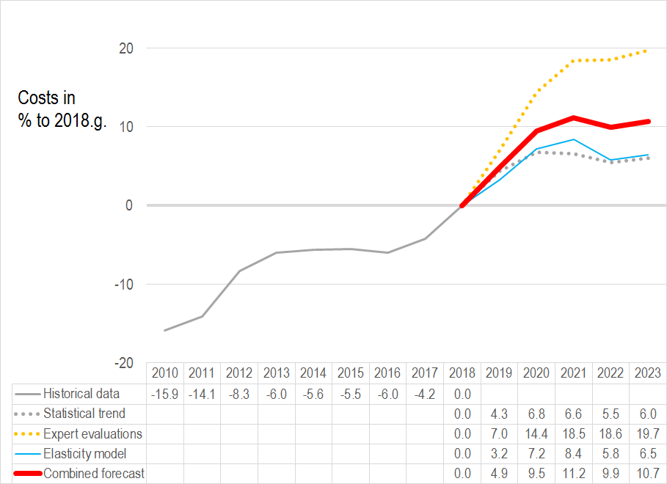
Source: CSB historical data before 2018 (inclusive) and calculations made by authors, based on expert evaluations, the statistical data trend and elasticity modelling – forecast for 2019-2023.
Evaluations of industry representatives show that a slower increase of changes in costs is expected in 2019 and 2020 (compared to the previous year) than in 2018. Furthermore, overall changes in costs will have increased almost by 20% in 2023, compared to 2018.
The statistical trend based on cyclic dynamics since 2010 without considering the drop during the economic crisis, shows a much more cautious forecast with a reduction in the increase of changes in costs in 2021 and 2022, which will result in a level of changes in costs by 6% higher than in 2018 in 2023. The cost-volume elasticity model, which includes evaluations of industry representatives on changes in the costs, if the volume of products changes, and causal relationships of historical data of this links was used to improve accuracy of forecasts (for a more detailed analysis of cost-volume and profit margin-volume models see Annex No. 1). This model shows cautious forecasts, which are very close to the statistical trend of changes in costs reaching an increase of only 6.5% in 2023 compared to 2018.
The rapid increase in the volume of construction products in recent years thanks to the implementation of project co-funded by EU funds, may increase the deficit of resources also in 2019 – 2021, which may have an unpredictable impact on the increase in changes in costs. Therefore, it is impossible to unambiguously state that the forecast evaluations of industry experts would be exaggerated. It is also difficult to forecast whether the drop of changes in costs after the implementation of projects co-financed by EU funds might be as slow as forecast of the statistical trend and elasticity. Or, quite the opposite – the drop in changes in costs due to inertial effects may be delayed due to the drop in the demand in volume. Actual changes in costs may largely depend on fluctuations in the volume of public orders and the extent to which state and local government projects without co-funding from EU funds level the drop in volume of co-financed projects.
Therefore, the approach defined in the improved methodology to take into account three data sources in the final forecast is considered justified and the combined forecast, which is formed as mean arithmetic value from three data sources, show an increase in each year of the period of forecast except 2022 (see Table No. 5).
Table No. 5. Combined forecast – changes in construction costs compared to the previous year, %
Year | 2019 | 2020 | 2021 | 2022 | 2023
Changes in construction costs compared to the previous year, % | 4.9 | 4.4 | 1.5 | -1.1 | 0.7
Source: calculations of the authors based on expert evaluations, the statistical data trend and elasticity modelling
The total trend of changes in construction costs is an annual increase of about 5% until 2020 followed by small fluctuations of changes at a zero level until 2023. The forecast for 2019 is confirmed by CSB data: The total level of changes in construction costs increased by 5.0% in Q1 2019, compared to Q1 2018.
However, it should be taken into account that actual changes in construction costs may be considerably affected by specific factors related to the deficit of resources in case of rapid implementation of large projects, for example, the demand for local gravel quarry resources in case of implementation of Rail Baltica, and specific market solutions, for example, attraction of labour force from “third countries” and state initiatives in the development of the construction sector and the implementation of shadow economy combating measures. Therefore, the forecasts should be interpreted as a general market trend, the real dynamics of changes in construction costs may be affected by specific factors and circumstances.

FORECASTS OF CHANGES IN COSTS OF CONSTRUCTION RESOURCES

Factors affecting changes in costs of labour force and construction materials
3.2.1. Factors affecting changes in costs of labour force and construction materials
In order to identify the most important factors affecting changes in construction costs, expert evaluations of the first and second round of interviews were evaluated on a 10-point scale, where the highest evaluation means the largest impact of the factor on changes in costs. 10 most important factors with the highest average score were selected for interviews after the first round of expert interviews, which were then evaluated by experts interviewed during the second round. Thus, a total evaluation of the impact of 10 factors on changes in costs of labour force and construction materials was obtained.
The volume of construction products was the most important factor affecting changes in labour costs in Latvia with the average score of 8.72 (see Figure No. 4).
Figure No. 4. Criticality of the factors affecting changes in labour costs (on a 10-point scale) and variation of expert evaluations (standard deviation)
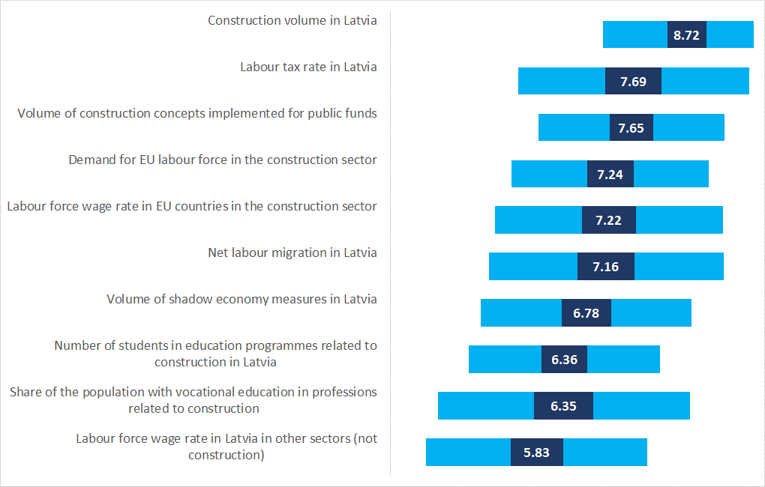
Source: Expert interviews

The next 5 most important factors with the average score of 7 to 8:
- Labour tax rate in Latvia;
- Volume of construction concepts implemented for public funds;
- Demand for EU labour force in the construction sector;
- Labour force wage rate in EU countries in the construction sector;
- Net labour migration in Latvia.
However, it should be noted that the sequence of importance of the factors cannot be evaluated as stable, because expert opinions varied comparatively largely, as evidenced by the standard deviation interval around the average value. For example, the unemployment rate, which is ranked 13th based on average evaluations, would be the 3rd most important factor according to evaluations of individual experts.
When considering the mean arithmetic standard error in the selection of the average evaluation of the factors affecting changes in costs of labour force and construction costs, it can also be concluded that the number in sequence of individual factors might differ. However, it is possible to differentiate factors in general, which have most or least impact on changes in costs of labour force and construction materials, i.e. the factors specified as the most important most likely are indeed the most important.
The volume of construction products was the most important factor affecting changes also in costs of construction materials in Latvia with the average score of 7.93 (see Figure No. 5). However, although the volume construction products is convincingly ranked first in case of changes in labour costs, variations are possible in case of changes in costs of construction materials.
Figure No. 5. Criticality of the factors affecting changes in costs of construction materials (on a 10-point scale) and variation of expert evaluations (standard deviation)
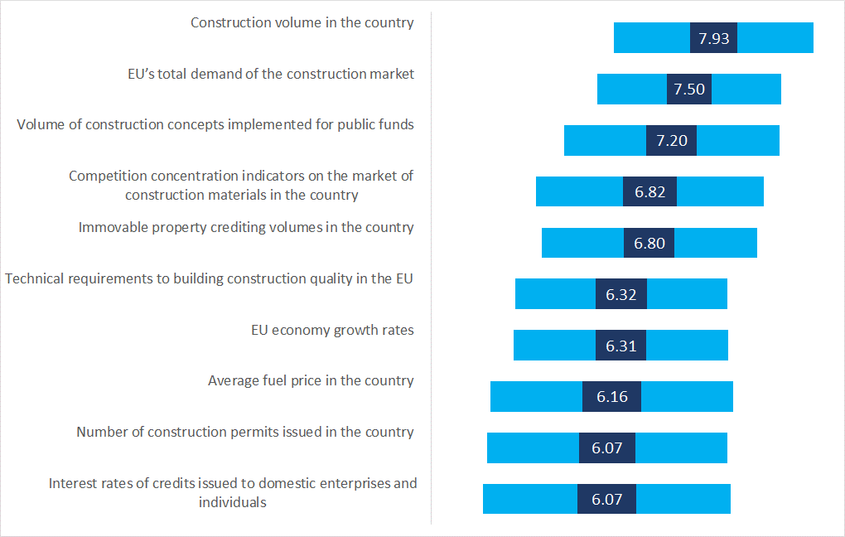
Source: Expert interviews
When reviewing mean arithmetic standard errors of the selection, it can be concluded that the EU’s total demand of the construction market could be the first as the most important factor affecting changes in costs of construction materials, if the number of observations increased, i.e. more experts were asked during interviews. As it was mentioned before, when analysing the factors affecting changes in costs of labour force, the sequence of other individual factors might differ as well, however, it may safely be said that five most important factors and five least important factors are as they are.
The next 5 most important factors by construction volume are:
- EU’s total demand of the construction market;
- Volume of construction concepts implemented for public funds;
- Competition concentration indicators on the market of construction materials in the country;
- Immovable property crediting volumes in the country;
- Technical requirements to building construction quality in the EU.
3.2.2. Impact of shadow economy combating measures on changes in costs of construction materials and labour force
After the first and second round of expert interviews total average evaluations of the impact of shadow economy combating measures on changes in costs of labour force (see Figure No. 6) and construction materials (see Figure No. 7) were summarised. Overall, all shadow economy combating measures have a positive effect on changes in costs of labour force and construction materials, i.e. the implementation of shadow economy combating measures increases changes in costs of construction materials and labour force. However, this effect is much more pronounced in terms of impact on changes in labour costs, where the criticality of impact of individual shadow economy combating measures differs multiple times.
Figure No. 6. Criticality of the impact of shadow economy combating measures on changes in costs of labour force (on a -10 to 10-point scale) and variation of expert evaluations (standard deviation)
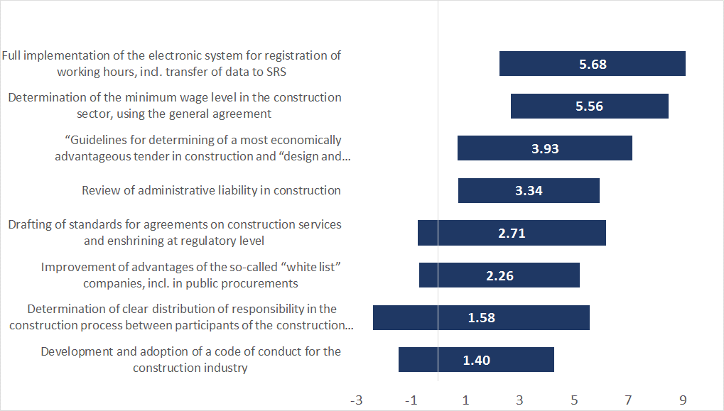
Source: Expert interviews

Changes in labour costs are most affected by two shadow economy combating measures:
- Full implementation of the electronic system for registration of working hours, incl. transfer of data to SRS;
- Determination of the minimum wage level in the construction sector, using the general agreement.
These measures, as well as the next two measures, the criticality of impact of which is much lower, were positively evaluated by most experts, however although their average evaluation is positive, individual experts evaluated negatively the effect of the last five shadow economy combating measures on changes in labour costs, i.e. the implementation of the measure reduces changes in labour costs.

Figure No. 7. Criticality of the impact of shadow economy combating measures on changes in costs of construction materials (on a -10 to 10-point scale) and variation of expert evaluations (standard deviation)
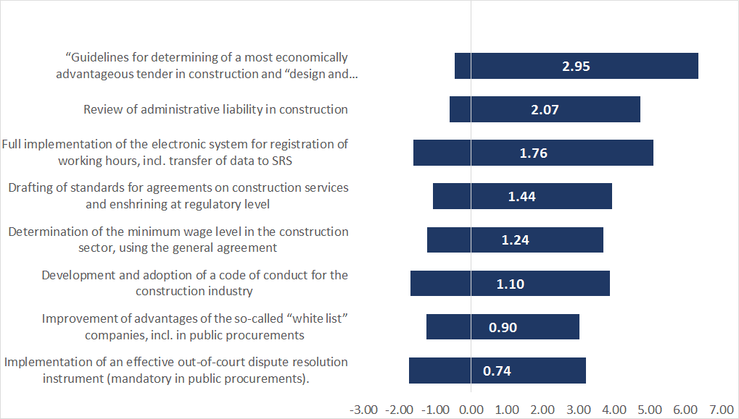
Source: Expert interviews
Unlike for the effect of shadow economy combating measures on changes in costs of labour force, some specific evidently the most important factor cannot be determined for changes in costs of construction materials due to similar average values in evaluations. Higher diversity of opinions is also observed in the evaluation the impact of the measures on changes in costs of construction materials, i.e. several experts evaluate the impact as negative although average evaluations are positive.

Summary of changes in costs of construction resources for forecasts
In 2018, an increase was observed in changes in construction costs in all types of resources, and the prepared forecasts evidence that this will continue also in 2019 and 2020 (see Figure No. 8). From 2021 changes in costs of construction materials and maintenance of machines and mechanisms are expected to stabilise at a level below 8% compared to 2018. Changes in costs of architectural and engineering activities will continue to cumulatively grow to 15.18% in 2023 compared to 2018. However, a stable constant increase is forecast for wages of workers reaching 20.39% in 2023 compared to the level of 2018.
Similarly to changes in construction costs as a whole, three individual sources of data demonstrate that evaluations of industry experts generally show a higher increase of change in costs than the statistical data trend and the cost-volume elasticity model. Taking into account the comparatively big variations in opinions of experts, the reason may be too intense perception of individual items of changes in costs, which have become much higher recently. However, taking into account market development and modifications in recent years, it is impossible to state that the statistical data trend and the cost-volume historical causal relationships would should a more accurate forecast. Therefore, in all three types of resources the combine forecast in the selected methodology will be the selected mean arithmetic value from all three sources of forecast data (see Table No. 6).

Figure No. 8. Changes in construction costs before 2018 and forecasts by types of resources from 2019 to 2023, cumulative changes compared to 2018, %
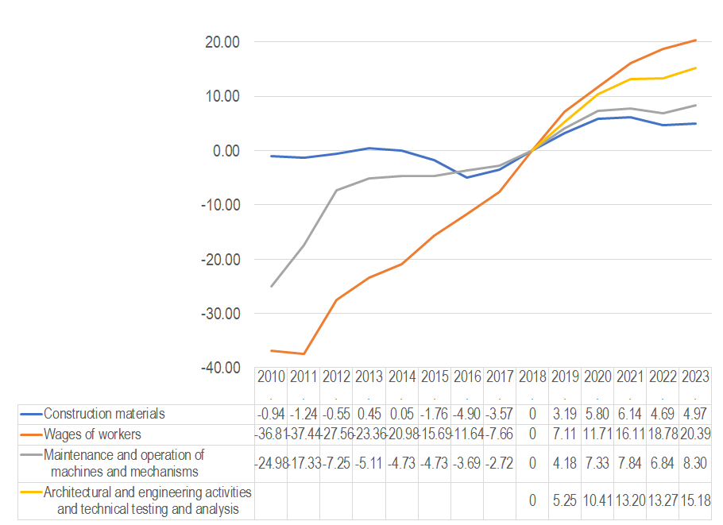
Source: CSB historical data before 2018 (inclusive) and calculations made by authors, based on expert evaluations, the statistical data trend and elasticity modelling – forecast for 2019-2023

Table No. 6. Combined forecast – changes in construction costs compared to the previous year, %
Year | 2019 | 2020 | 2021 | 2022 | 2023
Changes in construction costs compared to the previous year, % | 4.9 | 4.4 | 1.5 | -1.1 | 0.7
Source: calculations of the authors based on expert evaluations, the statistical data trend and elasticity modelling
The general trend in changes in construction costs broken down by types of resources is a stable increase for changes in costs of human resources, while changes in costs related to raw materials and equipment are expected to have higher elasticity depending on changes in the volume of construction products – after 2020 the forecast changes in costs will fluctuate around zero.
However, it should be taken into account that actual changes in construction costs by types of resources may be significantly influenced by specific demand and supply solution factors and it is expected that they will be more applicable to changes in costs of labour force and construction materials. Expert evaluations about the impact of shadow economy combating measures show that most impact is expected on the increase in changes in labour costs. This means that the size and dynamics of the increase in changes in labour costs also depends on the efficiency of implementation of shadow economy combating measures.

FORECASTS OF CHANGES IN THE VOLUME AND COSTS OF CONSTRUCTION PRODUCTS AND COSTS OF RESOURCES BY CONSTRUCTION SUBSECTORS

Forecasts of changes in costs of the subsector Construction of residential and non-residential buildings
When conducting interviews of construction experts in subsectors, companies engaged in construction of residential and non-residential buildings were united into one group of experts, taking into account that NACE Rev.2 classification does not differentiate individual codes of companies engaged in construction of residential and separately non-residential buildings. Moreover, specialisations of the companies is not so narrow and it would be therefore very difficult to separate each group.
In the subsector of residential and non-residential buildings forecasts expect an increase in volume in 2019 – 2023 with a potential drop in 2022, as well as there is a risk that the volume will drop in 2020 (see Figures No.9 and 10).
Figure No. 9. Changes in volumes of construction products in the subsector of residential buildings before 2018 and forecasts from 2019 to 2023, cumulative changes compared to 2018, %
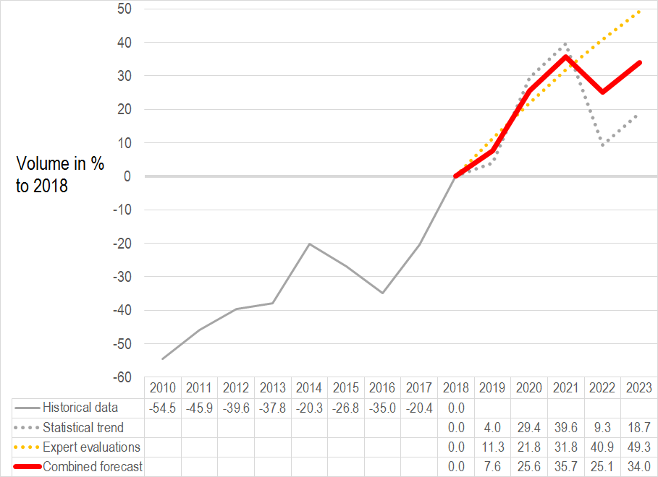
Source: CSB historical data before 2018 (inclusive) and calculations made by authors, based on expert evaluations and developed models – forecast for 2019-2023

Figure No. 10. Changes in volumes of construction products in the subsector of non-residential buildings before 2018 and forecasts from 2019 to 2023, cumulative changes compared to 2018, %
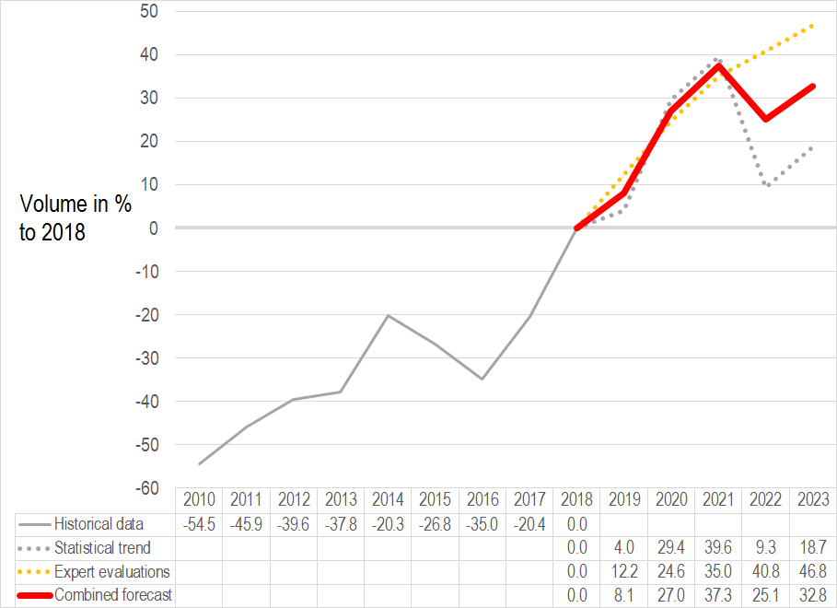
Source: CSB historical data before 2018 (inclusive) and calculations made by authors, based on expert evaluations and developed models – forecast for 2019-2023
The expert evaluation is the most optimistic in the sector of both residential and non-residential buildings – a cumulative increase in volume in 2023 would reach almost 50% of the level of 2018.
The statistical model points put to a significant risk of a drop in 2022, similarly to 2016, due to the cyclic nature of absorption of EU funds.
In sectors of residential and non-residential buildings forecasts show a very similar volume dynamics, which differs in some places within 2%. The data are similar due to two reasons: expert evaluations in both sectors are similar: specificity of CSB’s statistical registration – volumes of products in construction of residential and non-residential buildings are not registered separately, therefore the combined forecast in both sectors takes into account general CSB data on dynamics in the volume of construction products in construction of buildings.
Evaluations of public construction experts show a considerable drop in volumes after 2021 due to closure of absorption of EU funds within the current programming period. Therefore, there is reason to believe that part of interviewed subsector experts have not sufficiently taken into account the risks of fluctuations in public construction orders in their forecasts. This justifies the solution selected in the methodology – the final forecast is a combined forecast formed by the mean arithmetic value from both sources.
The combined forecast shows that the cumulative increase in volumes in 2023 will exceed 30% of the level of 2018 both in subsector of construction of residential and non-residential buildings.
Taking into account the forecast volume, as well as the expert evaluation and the statistical data trend in the subsector of residential and non-residential buildings, an increase in changes in costs is expected during the entire period from 2019 to 2023 (see Figures No. 11 and No. 12).

Figure No. 11. Changes in construction costs in the subsector of residential buildings before 2018 and forecasts from 2019 to 2023, cumulative changes compared to 2018, %
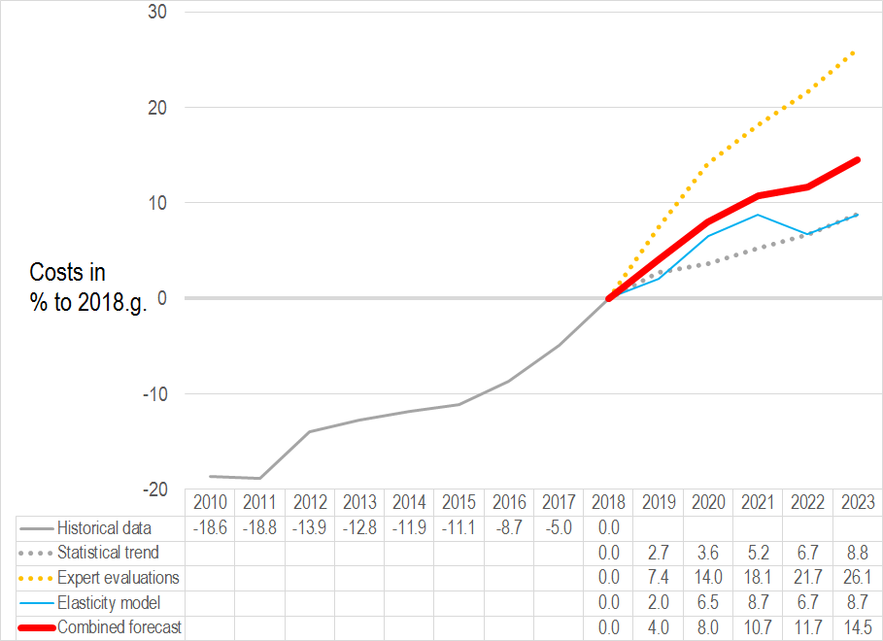
Source: CSB historical data before 2018 (inclusive) and calculations made by authors, based on expert evaluations and developed models – forecast for 2019-2023
Figure No. 12. Changes in construction costs in the subsector of non-residential buildings before 2018 and forecasts from 2019 to 2023, cumulative changes compared to 2018, %
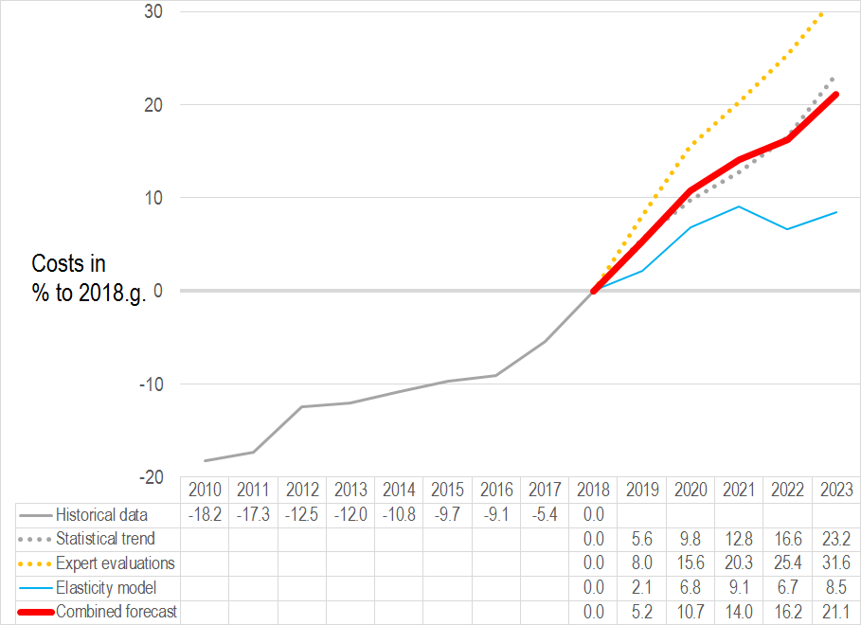
Source: CSB historical data before 2018 (inclusive) and calculations made by authors, based on expert evaluations and developed models – forecast for 2019-2023
The expert evaluation is the most optimistic – the cumulative increase of changes in costs in 2023 would reach 26.1% of the level of 2018 for residential buildings and 31.6% – for non-residential buildings.
The cost-volume elasticity model shows more cautious forecasts – a cumulative increase in volume in 2023 will reach 8.5% of the level of 2018.
The results of the statistical model are rather close to the results of the elasticity model for residential buildings, and is in the middle between expert evaluations and the results of the elasticity model for non-residential buildings. Differences in the results are related to differences in forecasts of construction volumes. Differences of the statistical data trend are also confirmed by indications of individual experts that a higher volume of public procurements is expected in the sector of non-residential buildings compared to the sector of residential buildings in the nearest years.
The combined forecast shows that the cumulative increase of changes in volumes of products in 2023 will reach around 14.5% of the level of 2018 for residential buildings and 21.1% – for non-residential buildings. However, it should be taken into account that these differences should be evaluated as conditional differences, because considerable sections in the changes of costs in both sectors overlap.
Opinions of experts in subsectors by types of resources show that the volume of construction products in Latvia is the most important factor, which will affect changes in labour costs. The resources available to the population and the share of professional construction education specialists in both sectors is in the second place, but the level of wages of labour force in Latvia in other sectors – in the third place. The factors affecting changes in costs of construction materials are similar except that the factors available only with financial resources are in the second place, but GDP dynamics is in the third place.
Table No. 7. Factors affecting changes in costs of labour force and construction materials
Factor affecting changes in costs of labour force in the subsector of construction of residential buildings | Average evaluation
Volume of construction products in Latvia | 7.83
Resources available to the population (own/bank, etc.) | 6.33
Share of the population with vocational education in professions related to construction | 5.75
Labour force wage rate in Latvia in other sectors (not construction) | 5.50

Factor affecting changes in costs of labour force in the subsector of construction of non-residential buildings | Average evaluation
Volume of construction products in Latvia | 7.92
Share of the population with vocational education in professions related to construction | 5.67
Resources available to the population (own/bank, etc.) | 5.25
Labour force wage rate in Latvia in other sectors (not construction) | 5.33

Factor affecting changes in costs of construction materials in the subsector of construction of residential buildings | Average evaluation
Volume of construction products in the country | 6.75
Immovable property crediting volumes in the country | 6.25
Resources available to the population (own/bank, etc.) | 6.00
Changes in gross domestic product in the country | 4.83

Factor affecting changes in costs of construction materials in the subsector of construction of non-residential buildings | Average evaluation
Volume of construction products in the country | 6.75
Immovable property crediting volumes in the country | 6.08
Resources available to the population (own/bank, etc.) | 5.17
Changes in gross domestic product in the country | 5.25
Source: Expert interviews
The evaluation of forecasts of changes of costs by types of resources by subsector experts is very close in sectors of residential and non-residential buildings and generally corresponds to the evaluation of the forecasts of changes in all construction costs by types of resources – a more rapid increase is expected in changes in the costs related to human resources. Unlike in the forecasts of changes in the total construction costs, a more stable increase is expected for changes in costs related to raw materials and equipment.
Figure No. 13. Forecast of changes in construction costs by types of resources in the subsector of residential buildings, cumulative changes compared to 2018, %
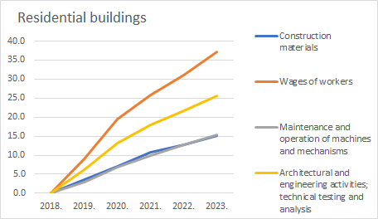
Source: CSB historical data before 2018 (inclusive) and calculations made by authors, based on expert evaluations and developed models – forecast for 2019-2023
Figure No. 14. Forecast of changes in construction costs by types of resources in the subsector of non-residential buildings, cumulative changes compared to 2018, %
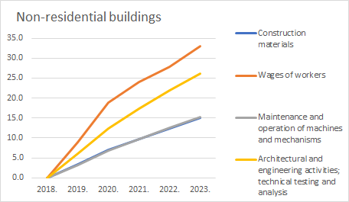
Source: CSB historical data before 2018 (inclusive) and calculations made by authors, based on expert evaluations and developed models – forecast for 2019-2023

Forecasts of changes in costs of the subsector Construction of transport objects
Forecasts for construction volumes in the sub-sector of transport construction have been developed on the basis of a more detailed methodology. The parties involved found that trends of road and bridge (“roads”) and railway infrastructure construction volumes are expected to reverse radically over the next 5 years. The improved methodology included forecasting roads and railways separately and merging for owerall sub-setor forecast. In order to do this, additional experts for detailed assessment were attracted.
A sharp drop in volume is forecasted for road infrastructure construction, which will start in 2020. Cumulative changes in road infrastructure construction against 2018 are expected to result in a slight increase of 4.2% in 2019 and a drop of 12.6% in 2020, 29.7% in 2021, 32.3% in 2022 (see Figure 15). This forecast relay on both statistical data and expert assessments. The statistical model points to a significant risk of decrease between 2020 and 2022, as it was in 2016 due to cyclical nature of EU funding investments. The data for the 2023 forecasts were too controversial to put forward a certain trend.
Figure No. 15. Changes in volumes of road construction products in the transport subsector before 2018 and forecasts from 2019 to 2023, cumulative changes compared to 2018, %
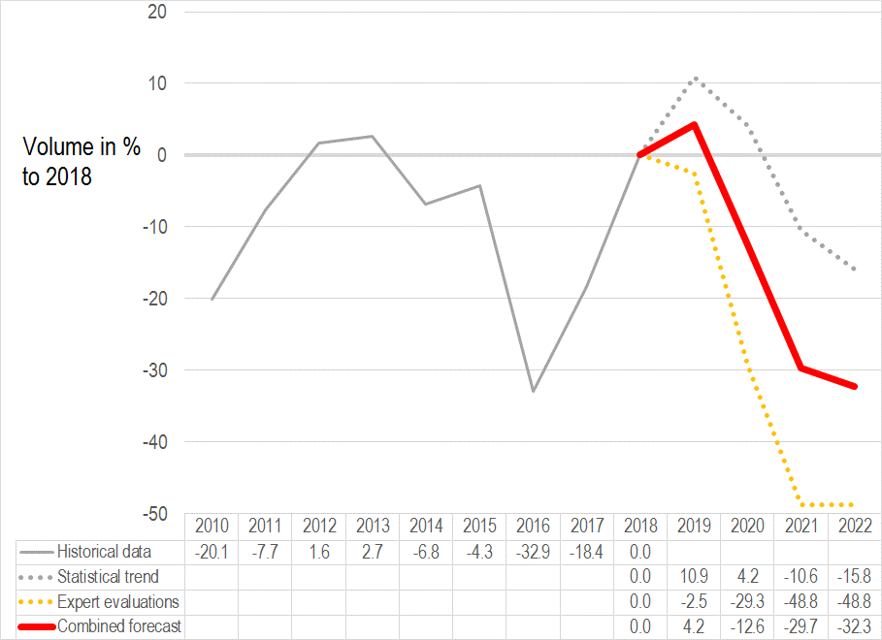
Source: CSB historical data before 2018 (inclusive) and calculations made by authors, based on expert evaluations and developed models – forecast for 2019-2022

A rapid increase in volume is expected in the construction of railway infrastructure (see Figure 16). This forecast is based on expert assessments which includes the planned railway infrastructure projects of the “Latvijas dzelzceļš” SSC and “European Railway Line” Ltd.

Figure No. 16. Changes in volumes of railway construction products in the transport subsector before 2018 and forecasts from 2019 to 2023, cumulative changes compared to 2018, %
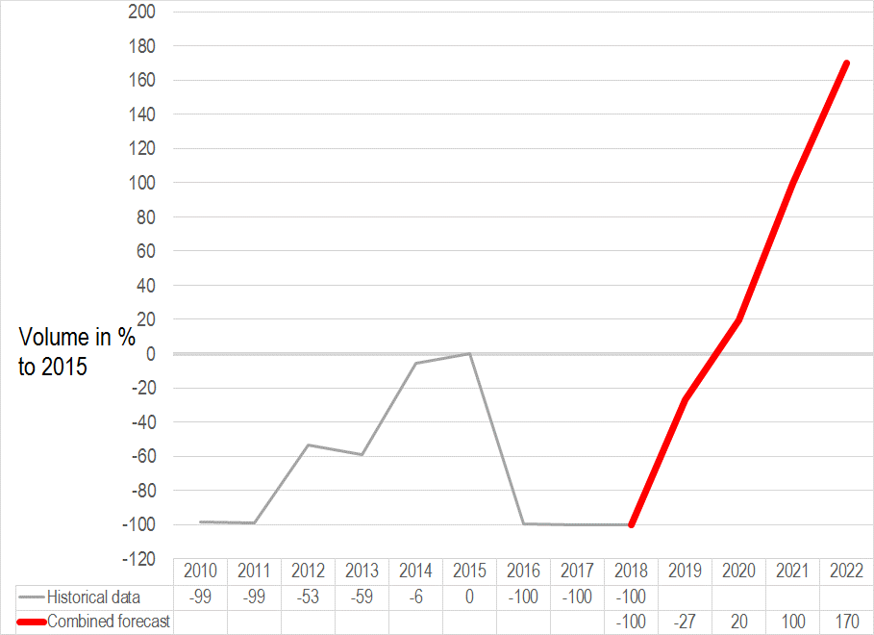
Source: CSB historical data before 2018 (inclusive) and calculations made by authors, based on expert assessments – forecast for 2019-2022
Considering the projected construction volume changes in the railway and road infrastructure subsectors, a variable dynamics and uneven developments in construction volumes are expected throughout the transport subsector as a whole between 2019 and 2022 (see Figure 17).
Figure No. 17. Changes in volumes of construction products in the transport subsector before 2018 and forecasts from 2019 to 2022, cumulative changes compared to 2018, %
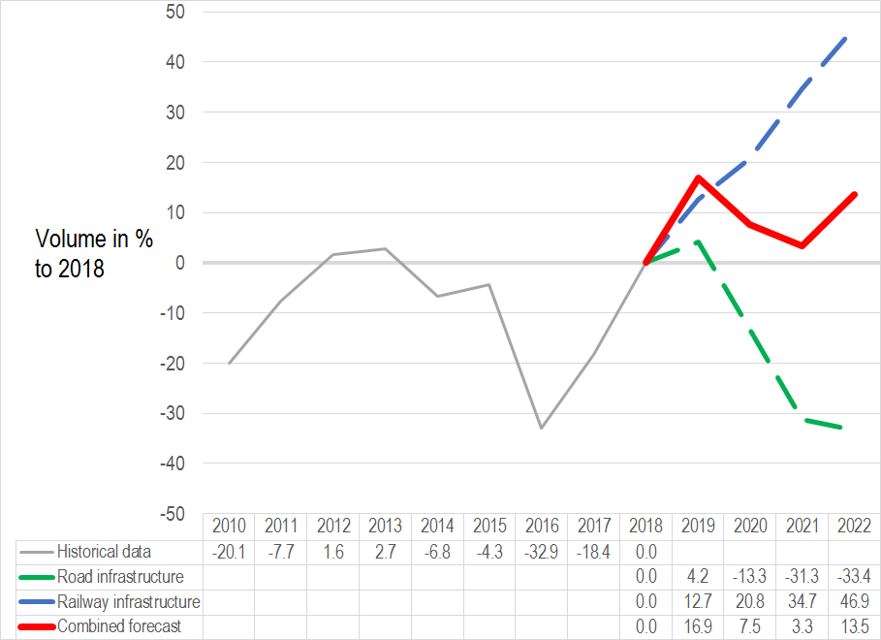
Source: CSB historical data before 2018 (inclusive) and calculations made by authors, based on expert evaluations and developed models – forecast for 2019-2022
Cumulative changes in construction volume against 2018 foresee an increase of 16.9% in 2019, a decrease in growth in 2020 and 2021 will be 7.5% and 3.3% respectively, and a growth of 13.5% in 2022. The data for the 2023 forecasts were too controversial to put forward a certain trend.
It is important to take into account the fact that road and railway construction areas have a minimal overlap between them. This means that the increase in construction volume in one of these areas has little impact on the other.
During the period when the construction volume of railway infrastructure is expected to increase due to the launch of major projects (RailBaltca, electrification of the railway, etc.), road infrastructure construction is expected to decrease between 2020 and 2022, as flow of EU funding stops. The construction sector of the road infrastructure depends largely on projects financed by the European Union. Significant construction volume decrease in road infrastructure could result in skilled workers going abroad. This could lead to a shortage of labour and an increase in costs later, when construction volumes will rise again.
The increase in construction costs in the transport subsector is expected to be close to 2018 level throughout the period 2019-2022, with cumulative changes to 2018 expected to increase by 4.1% in 2019, by 3.1% in 2020, by 1.1% in 2022 (see Figure 18).
Figure No. 18. Changes in construction costs in the transport subsector before 2018 and forecasts from 2019 to 2022, cumulative changes compared to 2018, %
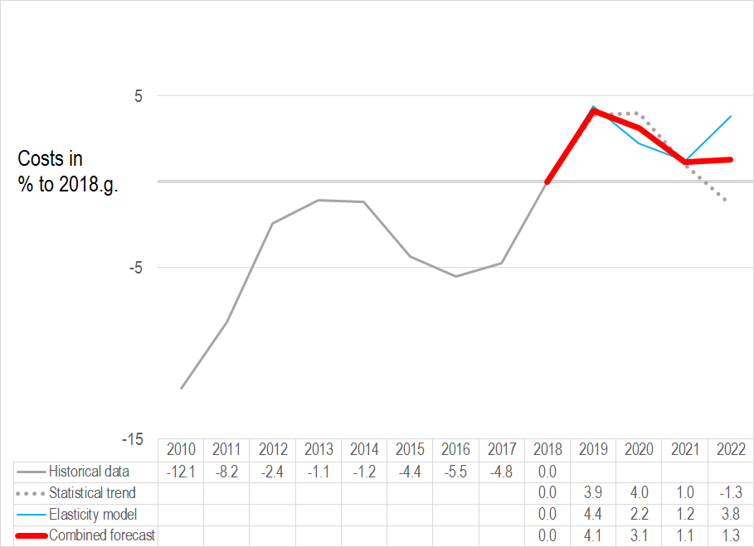
Source: CSB historical data before 2018 (inclusive) and calculations made by authors, based on expert evaluations and developed models – forecast for 2019-2022
In the 1st quarter of 2019 construction costs of transport objects increased by 5.5% compared to 1st quarter of 2018 according to CSB data, which is slightly higher than the combined forecast for 2019 as a whole. It should also be noted that, when major infrastructure projects are launched before or after 2023, the inadequately high demand for the supply of resources could lead to cost increase.
Opinions of experts in subsectors by types of resources show that the most important factors of changes in costs of labour force and construction materials are related to public construction plans – predictability, distribution of finances and regional distribution and volumes.
As to changes in labour costs, the implementation of the Rail Baltica project was also mentioned along with the availability of construction materials near the construction sites, which is mentioned among the most important factors of changes in costs of construction materials.
The volume of construction products in the country is also mentioned as one of the factors affecting changes in costs of construction materials, however it is not the priority factor.
Table No. 8. Factors affecting changes in costs of labour force and construction materials in the construction subsector
Factors affecting changes in costs of labour force in the subsector of construction of transport objects | Average evaluation
Unpredictable amount of financing in the long term and in the medium term (in the state road network and in local government) | 10.00
Uneven attraction/planning/use of EU funds in the construction industry within the programming period | 10.00
Advancement of the Rail Baltica project | 9.00
Factors affecting changes in costs of construction materials in the subsector of construction of transport objects | Average evaluation
Spending of available funding is not coordinated, uneven amount of funding to be absorbed in the specific time period | 10.00
Volume of construction concepts implemented for public funds | 10.00
Average fuel price in the country and changes in prices of oil products in the world | 9.00
Volume of construction products in the country | 7.00
Geographic availability of construction materials close to construction sites | 6.00
Source: Expert interviews
The evaluation of forecasts of changes in costs by types of resources differs from the forecast of changes in the total construction costs – there is slightly higher increase projected in 2020 compared to 2019. The general trend is 1-5% above 2018 level until 2022 (see Figure 19). Exeption is costs related to architectural activities and technical testing, where a more rapid increase is forecasted in 2022. The 2023 forecasts show conflicting trends and therefore the final forecast for 2023 is not included. Moreover, additionally invited experts in the road and rail fields did not assess cost estimates in detail by type of resource. Significant cost fluctuations are possible from 2023, which will depend on the practical progress of major transport infrastructure construction projects.
Figure No. 19. Forecast of changes in construction costs by types of resources in the subsector of transport objects, cumulative changes compared to 2018, %
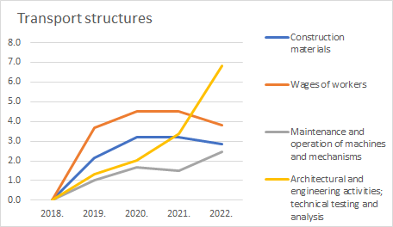
Source: CSB historical data before 2018 (inclusive) and calculations made by authors, based on expert evaluations and developed models – forecast for 2019-2022

Forecasts of changes in costs of the subsector of construction of main underground pipelines
An increase in volume in 2019 and 2020 is expected in the subsector of main underground pipelines. In later years expert evaluations and the statistical trend differ significantly (see Figure No. 20). The expert evaluation is the most moderate – without significant fluctuations after 2019. The statistical model points out to a significant risk of a drop in 2022 and 2023, similarly to 2016, due to the cyclic nature of absorption of EU funds.
The combined forecast shows that the cumulative increase in volume during the period will fluctuate within 8% to 23% of the level of 2018 with a reduction in volume by 13% in 2022. Taking into account indications of individual experts about the dynamics of public procurement plans, a bigger drop in the volume of orders is expected around 2021.
Therefore, the combined forecast is more to be interpreted not as a set of individual annual forecasts, but as a general trend, where the risk of reduction in volume is expected after the increase in volume in 2019 and 2020.
Figure No. 20. Changes in volumes of construction products in the subsector of main underground pipelines before 2018 and forecasts from 2019 to 2023, cumulative changes compared to 2018, %
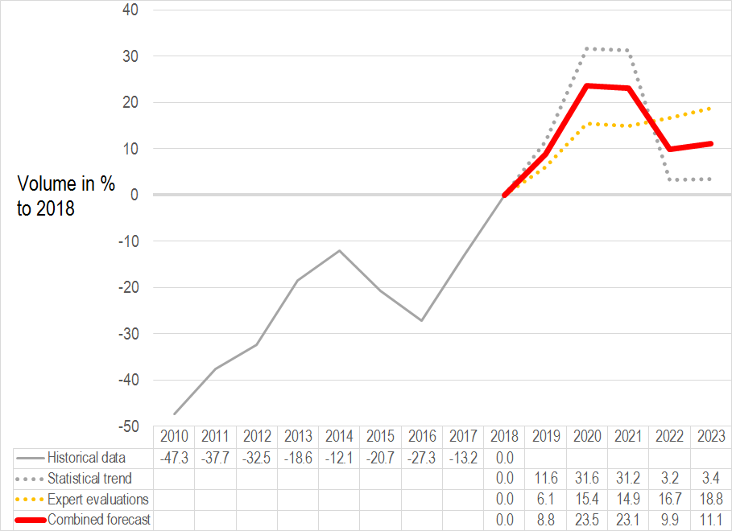
Source: CSB historical data before 2018 (inclusive) and calculations made by authors, based on expert evaluations and developed models – forecast for 2019-2023

Figure No. 21. Changes in construction costs in the subsector of main underground pipelines before 2018 and forecasts from 2019 to 2023, cumulative changes compared to 2018, %
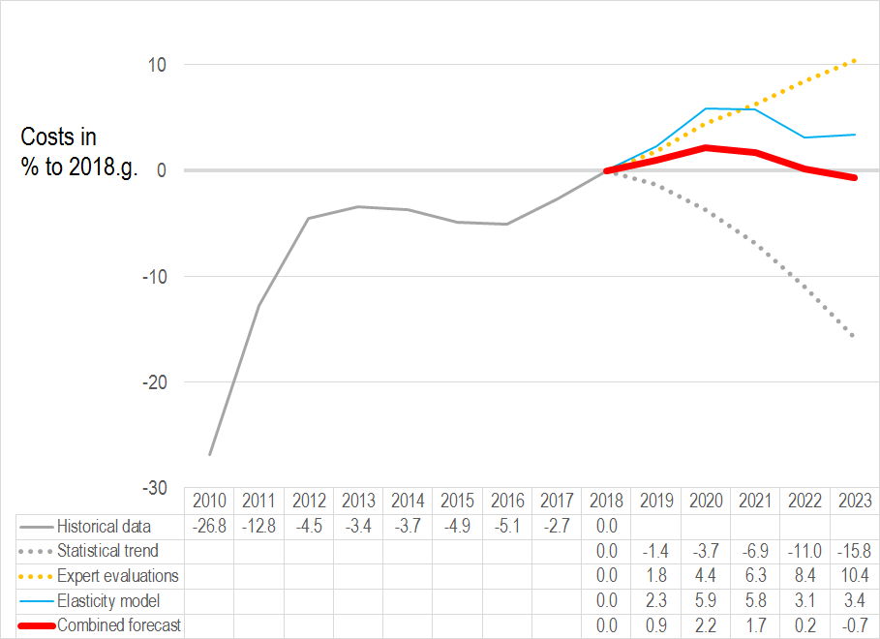
Source: CSB historical data before 2018 (inclusive) and calculations made by authors, based on expert evaluations and developed models – forecast for 2019-2023
Opinions of experts in subsectors by types of resources show that the most important factors in changes of costs of labour force and construction products are volumes of construction products in Latvia, including public.
As to changes in labour costs, shortage of labour force is in the first place.
Fuel prices, availability of steel raw materials and equipment are mentioned as factors affecting changes in costs of construction materials.
Table No. 9. Factors affecting changes in costs of labour force and construction materials in the construction subsector
Factors affecting changes in costs of labour force in the subsector of construction of main underground pipelines | Average evaluation
Shortage of labour force | 8.75
Volume of construction concepts implemented for public funds | 8.75
Volume of construction products in Latvia | 7.50
Labour force wage rate in EU countries in the construction sector | 6.50

Factors affecting changes in costs of construction materials in the subsector of construction of main underground pipelines | Average evaluation
Volume of construction concepts implemented for public funds | 7.00
Volume of construction products in the country | 6.75
Average fuel price in the country, increase in prices of oil products, electricity price | 6.50
Availability of steel raw materials and pipe fittings and the level of prices in the EU market | 6.50
Availability of technological equipment, delivery time and the level of prices in the EU market | 6.25
Source: Expert interviews
The evaluation of forecasts of changes in costs by experts of the subsector by types of resources shows a stable increase of costs in all types of resources. Similarly, to construction in general, the largest increase is expected in the areas related to human resources, however, changes in costs of construction materials and maintenance and operation of machines and mechanisms will stably grow relatively more than construction in general.
Figure No. 22. Forecast of changes in construction costs by types of resources in the subsector of main underground pipelines, cumulative changes compared to 2018, %
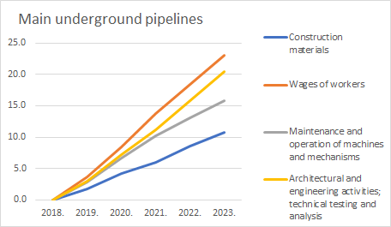
Source: CSB historical data before 2018 (inclusive) and calculations made by authors, based on expert evaluations and developed models – forecast for 2019-2023

Differences are observed when comparing general changes in costs in the subsector with changes in costs broken down by types of resources – the breakdown by resources shows a higher increase in costs. There are two reasons for that:
experts’ own evaluations about the subsector in general show lower values of increase in costs that when evaluating resources separately;
the general forecast of changes in costs of the subsector is formed by three sources, incl. the statistical trend and the elasticity model, while the source for the breakdown of costs by types of resources contain are expert evaluations only.
Therefore, when interpreting the forecasts, it should be taken into account that the results broken down by types of resources may have lower values in the first years of the forecast period than shown by the results of expert interviews.

Forecasts of changes in costs of the subsector of other civil engineering projects
Huge volume fluctuations by years have historically been observed in the subsector of other civil engineering projects, which prevent from making credible short-term forecasts (see Figure No.23). The expert evaluation was selected as a leitmotif of the forecasts for the subsector, which expects a considerable drop in volume after 2021 reaching a cumulative drop of - 31% in 2023 compared to the level of 2018.

Figure No. 23. Changes in volumes of construction products in the subsector of other civil engineering projects before 2018 and forecasts from 2019 to 2023, cumulative changes compared to 2018, %
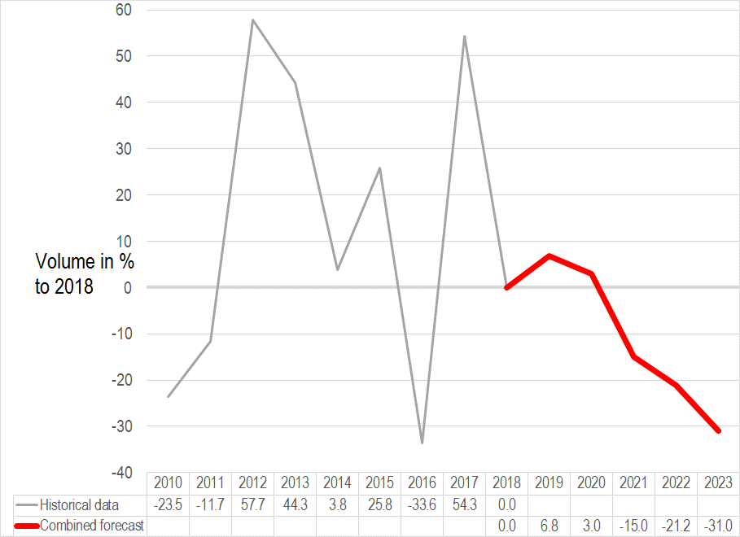
Source: CSB historical data before 2018 (inclusive) and calculations made by authors, based on expert evaluations – forecast for 2019-2023
Taking into account the forecast changes in volume, as well as the expert evaluation and the statistical data trend in the subsector of other civil engineering projects, for the period from 2019 to 2023 each data source shows different dynamics in forecasts of changes in costs (see Figure No. 24).
The expert evaluation shows a stable, yet moderate increase in changes in costs up to 15% in 2023 compared to the level of 2018. The cost-volume elasticity model shows a reduction of changes in costs from 2021. The statistical model shows a reduction of changes in costs throughout the entire period. Since the historical time series shows a wave drop in a longer period of time, then the model forecasts the drop also in a longer future period. However, this has no unambiguous economic justification, and therefore the forecasts of the model are more important in the nearest years.
The combined forecast shows that a small cumulative increase of changes in costs in 2019 and 2020 will be followed by a drop of changes in costs until 2023. Taking into account huge annual fluctuations of the construction volume, as well as peculiarities of the statistical model in the subsector, the forecast after 2020 have not stable reasonable justification. In accordance with CSB data, the level changes in costs of engineering projects increased by 4.9% in Q1 2019, compared to Q1 2018, which is more in line with expert evaluations.

Figure No. 24. Changes in construction costs in the subsector of other civil engineering projects before 2018 and forecasts from 2019 to 2023, cumulative changes compared to 2018, %
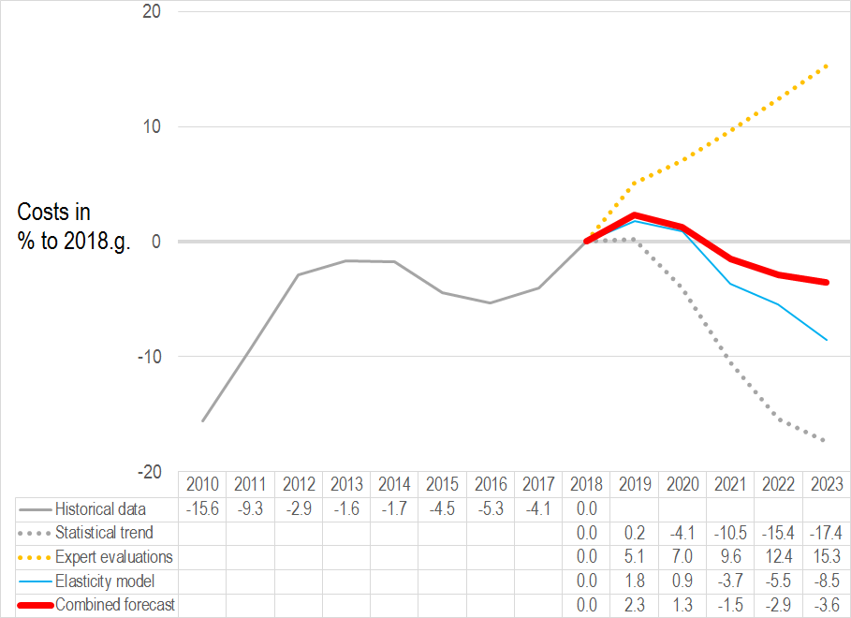
Source: CSB historical data before 2018 (inclusive) and calculations made by authors, based on expert evaluations and developed models – forecast for 2019-2023.
Opinions of experts in subsectors by types of resources show that the most important factors in changes of costs of labour force and construction products are volumes of construction products in Latvia (see Table No. 10).
As to changes in labour costs, the level of labour taxes, the share and deficit of qualified labour force are also important.
Fuel prices, availability of labour force are mentioned as factors affecting changes in costs of construction materials, which have indirect influence of prices of construction materials.
Table No. 10. Factors affecting changes in costs of labour force and construction materials in the construction subsector
Factors affecting changes in costs of labour force in the subsector of construction of other civil engineering projects | Average evaluation
Volume of construction products in Latvia | 9.25
Labour tax rate in Latvia | 8.50
Share of qualified labour force with education/experience in the subsector of construction of other civil engineering projects | 7.50
Increase of competition between employers for qualified labour forces on the labour market | 7.50
Factors affecting changes in costs of construction materials in the subsector of construction of other civil engineering projects | Average evaluation
Availability of labour force | 8.25
Volume of construction products in the country | 7.25
Fuel price | 7.25
Source: Expert interviews
The evaluation of forecasts of changes in costs by experts of the subsector by types of resources generally shows more rapid dynamics at the beginning and at the end of the forecast period. Similarly to construction in general, changes in costs related to human resources will increase the most, however the difference from other types of resources is negligible. A minimum drop is forecast for construction materials in 2022 and 2023.
Figure No. 25. Forecast of changes in construction costs by types of resources in subsector of other civil engineering objects, cumulative changes compared to 2018, %
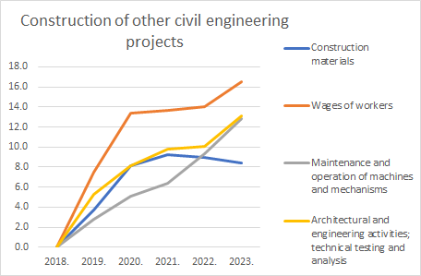
Source: CSB historical data before 2018 (inclusive) and calculations made by authors, based on expert evaluations and developed models – forecast for 2019-2023
Differences are observed when comparing general changes in costs in the subsector with changes in costs broken down by types of resources – the breakdown by resources shows a higher increase in costs. The reasons is that the general forecast of changes in costs of the subsector is formed by three sources, incl. the statistical trend and the elasticity model, while the source for the breakdown of costs by types of resources contain are expert evaluations only.
Therefore, when interpreting the forecasts, it should be taken into account that the results broken down by types of resources may have lower values in the first years of the forecast period than shown by the results of expert interviews.

Forecasts of changes in costs of the subsector construction of complex structures in industrial manufacturing companies
In the subsector of complex structures, CSB does not summarise statistical data on the volume of construction products (see Figure No.26). The expert evaluation was selected as a leitmotif of the forecasts for the subsector, which expects a stable increase, cumulatively exceeding 30% in 2023 compared to the level of 2018.

Figure No. 26. Changes in volumes of construction products in the subsector of complex structures before 2018 and forecasts from 2019 to 2023, cumulative changes compared to 2018, %
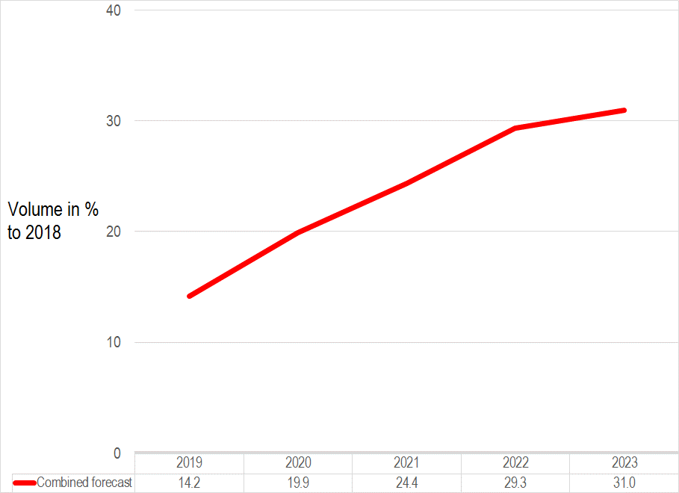
Source: CSB historical data before 2018 (inclusive) and calculations made by authors, based on expert evaluations and developed models – forecast for 2019-2023.

Taking into account the forecast changes in volume, as well as the expert evaluation, for the period from 2019 to 2023 each data source shows a stable increase in forecasts of changes in costs, but at different rates (see Figure No. 27).
The expert evaluation is the most moderate – the increase in 2019 and 2020 to the level of 12% compared to 2018 will be followed by a slow increase by 14% in 2023 compared to 2018.
The elasticity model of changes in costs based on volume forecasts shows lower changes in costs until 2020, and higher – after 2020.
The combined forecast shows a stable increase up to 22% in 2023. Taking into account that there are no other references in this subsector, it is hard to justify specific values of the forecast, however, the general trend shows a stable increase of changes in costs in the period of forecasts.

Figure No. 27. Changes in construction costs in the subsector of complex structures before 2018 and forecasts from 2019 to 2023, cumulative changes compared to 2018, %
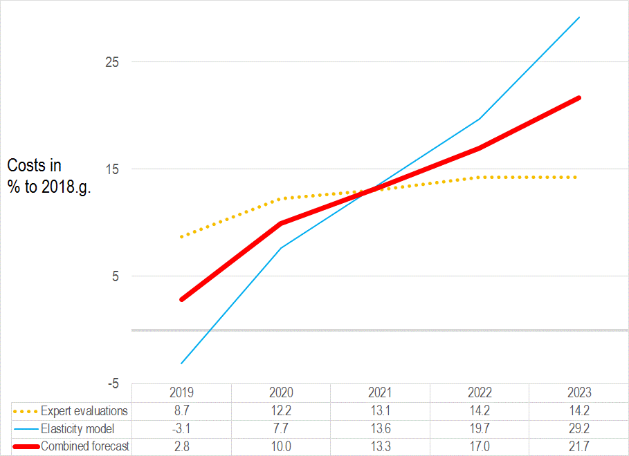
Source: CSB historical data before 2018 (inclusive) and calculations made by authors, based on expert evaluations and developed models – forecast for 2019-2023
As to the factors affecting changes in costs of labour force, experts indicate the demand for qualified employees and shortage of specialists as most significant factors (see Table No. 11).
The demand for construction materials, quality requirements and control mechanisms are mentioned as factors affecting changes in costs of construction materials.
Table No. 11. Factors affecting changes in costs of labour force and construction materials in the construction subsector
Factors affecting changes in costs of labour force directly in complex structures in manufacturing companies | Average evaluation
Demand for qualified employees | 9.25
Shortage of specialists as the construction market is growing | 9.25
Factors affecting changes in costs of construction materials directly in complex structures in manufacturing companies | Average evaluation
Demand for construction material resources | 7.75
Quality requirements | 6.75
Control | 6.00
Source: Expert interviews
The evaluation of forecasts of changes of costs by types of resources by subsector experts generally shows a rapid increase in changes in costs until 2020, followed by more moderate increase, structurally similar to the forecasts of changes in all construction costs by types of resources, however on a larger scale.

Figure No. 28. Forecast of changes in construction costs by types of resources in the subsector of complex structures, cumulative changes compared to 2018, %
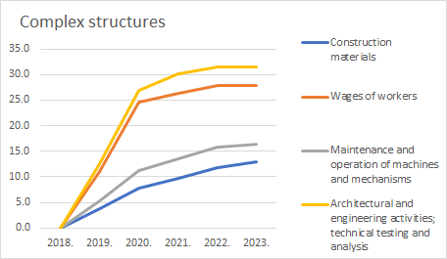
Source: CSB historical data before 2018 (inclusive) and calculations made by authors, based on expert evaluations and developed models – forecast for 2019-2023

Summary of forecasts of changes in costs by subsectors
When evaluating the increase of changes in costs by construction subsectors, the highest increase is expected in non-residential buildings – 21.1% and in complex structures – 21.7%, cumulatively in 2023 compared to the level of 2018 (see Figure No. 29).
Figure No. 29. Changes in construction costs before 2018 and forecasts by construction subsectors from 2019 to 2023, cumulative changes compared to 2018, %
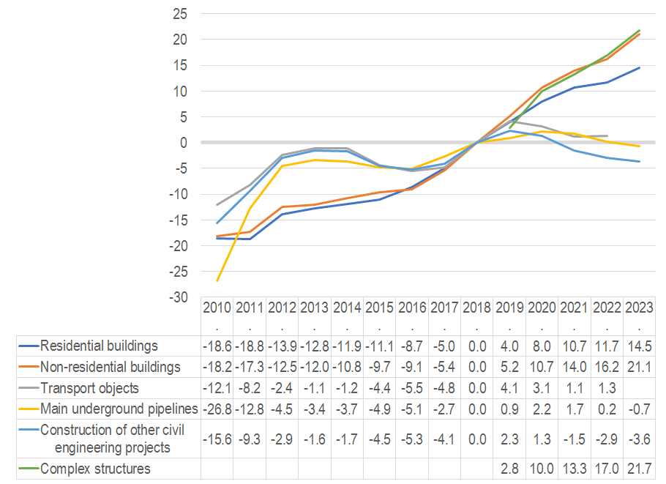
Source: CSB historical data before 2018 (inclusive) and calculations made by authors, based on expert evaluations and developed models – forecast for 2019-2023
A moderate increase of changes in costs up to cumulative 14.5% of the level of 2018 is forecast for residential buildings. Changes in costs of main underground pipelines will, on the contrary, gradually reduce after the rise in 2020.
Forecasts of changes in costs of subsectors of main underground pipelines, other civil engineering projects and transport evidence of fluctuations within 5% throughout the entire period of the forecast compared to the level of 2018.

MAIN RESULTS
- The total increase in the volume of construction products compared to the previous year will increase by 12.5% in 2019, by 14.8% in 2020, by 4.1% in 2021, reduced by -9,2% in 2022 and increase by 2.2% in 2023. Cumulative changes in the total volume of construction products will reach an increase of 24.7% in 2023 compared to 2018.

- The total changes in construction costs compared to the previous year will increase by 4.9% in 2019, by 4.4% in 2020, by 1.5% in 2021, reduced by -1,1% in 2022 and increase by 0.7% in 2023. Cumulative total changes in construction costs will reach an increase of 10.7% in 2023 compared to 2018.
- In the expert evaluation, the most important factors affecting changes in costs of labour force in the construction industry in 2019 – 2023 in Latvia are:
  - Volume of construction products in Latvia,
- Labour tax rate in Latvia,
- Volume of construction products implemented for public funds.
- In the expert evaluation, the most important factors affecting changes in costs of construction materials in the construction industry in 2019 – 2023 in Latvia are:
- Volume of construction products in Latvia,
- EU’s total demand of the construction market,
- Volume of construction products implemented for public funds.
- In the subsector of residential buildings, in the period from 2019 to 2023, an increase is expected in the volume of construction products, cumulative changes compared to 2018 provide for an increase by 7.6% in 2019, by 25.6% in 2020, by 35.7% in 2021, by 25,1% in 2022 and increase by 34% in 2023. In the subsector of residential buildings a homogeneous increase in changes in construction costs is expected throughout the entire period from 2019 to 2023, cumulative changes compared to 2018 provide for an increase by 4% in 2019, by 8% in 2020, by 10.7% in 2021, by 11,7% in 2022 and by 14.5% in 2023.
- In the subsector of non-residential buildings, in the period from 2019 to 2023, an increase is also expected in the volume of construction products with cumulative changes in 2019 compared to 2018 showing an increase by 8.1%, by 27% in 2020, by 37.3% in 2021, by 25,1% in 2022 and increase by 32.8% in 2023. In the subsector of non-residential buildings a homogeneous increase in changes in construction costs is expected throughout the entire period from 2019 to 2023 with cumulative changes in 2018 providing for an increase by 5.2% in 2019, by 10.7% in 2020, by 14% in 2021, by 16,2% in 2022 and increase by 21.1% in 2023.
- In the subsector of transport infrastructure, a radically opposed change in construction volume is expected in the road/ bridge and rail sector, with cumulative achievements of -33.4% and 46.9% against 2018 levels in 2022, respectively. Construction costs are projected to total 1-4% above 2018 levels by 2022. However, it is essential that the interchangeability of the workforce in road and rail areas is assessed to be minimal. In 2023, the forecasts are controversial and are based on the various expectations about the progress of major infrastructure projects. Considering both these aspects, significant cost fluctuations may occur for specific areas of expenditure up to 2023.

- In the subsector of construction of main underground pipelines, an increase is expected in the volume of construction products, cumulative changes compared to 2018 expect an increase by 8.8% in 2019, by 23.5% in 2020, by 23.1% in 2021, by 9.9% in 2022 and by 11.1% in 2023. Cumulative changes in construction costs compared to 2018 will forecast an increase by 0.9% in 2019, by 2.2% in 2020, by 1.7% in 2021, by 0,2% in 2022 and a reduction by -0.7% in 2023.
- In the subsector of other civil engineering projects, cumulative changes compared to 2018 expect an expert forecast of 6.8% in 2019, a small reduction in the increase by 3% in 2020 and a considerable drop in the volume of construction products after 2021 (-15%), -21.2% in 2022, reaching a cumulative drop of -31% in 2023 compared to the level of 2018. Similar trends are expected in construction costs with cumulating changes compared to 2018 forecasting an increase by 2.3% in 2019, by 1.3% in 2020, a reduction by -1.5% in 2021, by -2,9% in 2022 and by -3.6% in 2023.
- In the subsector of complex structures, an homogeneous increase in the volume of construction products is forecast: by 14.2% in 2019, by 19.9% in 2020, by 24.4% in 2021, by 29,3% in 2022 and a reduction by 31% in 2023. Cumulative changes in construction costs compared to 2018 provide for a homogeneous increase throughout the entire period from 2019 to 2023 with an increase by 2.8% in 2019, by 10% in 2020, by 13.3% in 2021, by 17% in 2022 and by 21.7% in 2023.
- Among all types of resources construction materials are expected to have lower changes in costs, cumulative changes compared to 2018 expect an increase of changes in costs by 3.19% in 2019, by 5.8% in 2020, by 6.14% in 2021, by 4,69% in 2022 and increase by 4.97% in 2023.
- A more rapid increase in costs of wages of workers is expected, cumulative changes compared to 2018 expert an increase from 7.11% in 2019 up to 20.39% in 2023. With a homogeneous increase by 11.71% in 2020, by 16.11% in 2021 and by 18.78% in 2022.
- Changes in costs of maintenance and operation of machines and mechanisms are moderate compared to 2018 with an increase by 4.18% in 2019, by 7.33% in 2020, by 7.84% in 2021, by 6,84% in 2022 and by 8.30% in 2023.
- Changes in costs of architectural and engineering activities; technical testing and analysis are expected to have a rapid increase from 5.25% in 2019 up to 15.18% in 2023. Therefore, an increase of 10.41% in 2020, by 13.2% in 2021, by 15.18% in 2022 is expected compared to 2018.

CONCLUSIONS
1. The forecasts provide that the total volume of construction products will increase by more than 10% in 2019 and 2020 compared to the previous year, and a drop in the increase and a drop in volumes is expected after 2021.
2. The increase in total volumes of construction products will directly affect changes in costs, which will increase by about 5% in 2019 and 2020 compared to the previous year, and might even reduce in 2022.
3. The forecasts provide that wages of workers will increase the most among all types of resources and may reach a cumulative increase of 20% in 2023 compared to the level of 2018, but changes in costs of architectural and engineering activities and technical testing and analysis – a 15% increase. Changes in costs of construction materials and maintenance and operation machines and mechanisms will reach a cumulative increase of 6-7% in 2020 compared to the level of 2018 and will almost remain unchanged.
4. The subsectors, where the forecasts expect to have the highest increase in costs are buildings and complex structures, where a more rapid increase in 2019 and 2020 will be replaced by a slower increase. The second group includes transport objects, underground main pipelines and construction of other civil engineering projects, whether an increase in 2019 and 2020 will be followed by a decline or fluctuation around the zero level of changes in costs.
5. Volumes of construction products are the main factor affecting changes in labour force and construction costs in Latvia.
6. The scope of public procurement in construction has significant effect on the construction sector due to its share. The risk of significant drop of the scope of public procurement in construction is forecast after 2020, if the volume dynamics is similar to the previous EU funds programming period after 2014, and the drop in the volume of project co-financed by EU funds is not replaced with state, local government, private sector projects and projects started in the new EU funds programming period in a timely manner. This is crucial for road infrastructure building subsector.
7. Total volumes of construction products will depend on market elasticity adapting to the deferred private demand in 2018-2020.
8. Forecasts of changes in costs evidence that the level of construction costs is expected to remain practically unchanged also after 2020, similarly to 2014-2016. Therefore there is a significant risk that private demand will not immediately replace the drop in public procurement and a significant drop in construction volumes is possible.
9. It is recommended to use public order as a tool for balance of market fluctuations.
10. The implementation of shadow economy combating measures increases changes in costs of construction materials and labour force. However, this effect is much more pronounced in terms of the effect on changes in labour costs, it is most affected by two shadow economy combating measures: the full implementation of the electronic system for registration of working hours, incl. transfer of data to SRS, and determination of the minimum wage level in the construction sector, using the general agreement. Unlike for the effect of shadow economy combating measures on changes in costs of labour force, some specific evidently the most important factor cannot be determined for changes in costs of construction materials due to similar average values in evaluations.
11. If we compare the forecasts of the study for 2019 with the study for 2018, the forecasts of increase in volumes of construction products have become considerably more cautious in the context of the entire period of the forecasts, and the increase in construction costs is therefore forecast at a lower level – the five-year annual average forecast for an increase in construction costs reduced from 4.3% to 2.1%.

ANNEXES
Annex No. 1 “Detailed analysis”.
Annex No. 2 “Research methodology”.
Annex No. 3 “List of construction industry experts interviewed during the study”.

https://www.em.gov.lv/lv/nozares_politika/buvnieciba/statistika__petijumi/
https://www.em.gov.lv/lv/nozares_politika/buvnieciba/statistika__petijumi/
Calculated from “BUG010. Volume indices and changes in volume of construction production”, CSB, http://data1.csb.gov.lv/pxweb/lv/rupnbuvn/rupnbuvn__buvn__ikgad/BUG010.px/
Expert evaluations.
Results of interviews with 20 experts in general construction carried out within the scope of the study.
Calculated using the CSB data: RC091c. Construction cost indices and changes by constructions groups by quarter, http://data1.csb.gov.lv/pxweb/lv/ekfin/ekfin__RCI__isterm/RC091c.px/
NACE: Statistical classification of economic activities in the European Community, Revision 2. Last accessed: 16.08.2018. Address: https://www.csb.gov.lv/lv/statistika/klasifikacijas/nace-2-red/kodi

