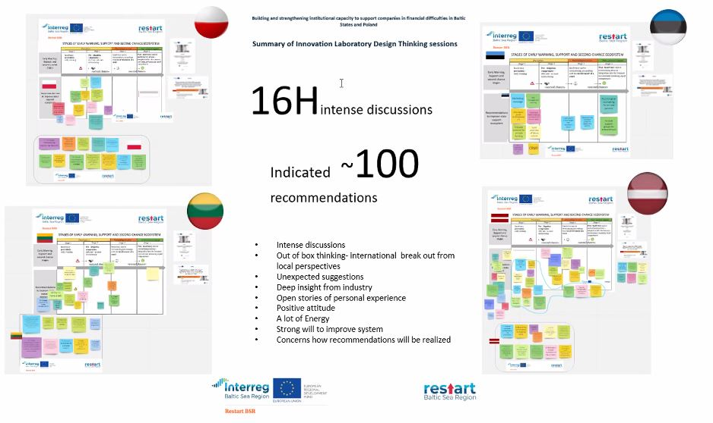
An international innovation laboratory is developing recommendations for early warning and support for companies in difficulty
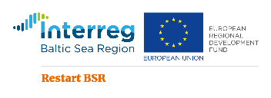
#restartbsr #Restart #BSR #Interreg #BalticSeaRegion #innovationlaboratory
On November 23-26, 2020, within the framework of the Interreg Baltic Sea Region Transnational Cooperation Program project RestartBSR, the first international Innovation Laboratory - Building and strengthening institutional capacity to support companies in financial difficulties in the Baltic States and Poland, bringing together RestartBSR project participants, entrepreneurs, representatives of state institutions and non-governmental organizations from Latvia, Lithuania, Estonia, Poland, Denmark, Hungary, Germany, etc.
During the first day of the Innovation Laboratory, the participants got acquainted with the results of the RestartBSR project - the study “Research of the best European support, early warning and second-chance systems transferability in the Baltic Sea region countries”, the tools developed by the RestartBSR project for entrepreneurs and mentors, as well as the progress of the Latvia, Lithuania, Estonia and Poland in the implementation of the RestartBSR project. During the second and third days, working groups of representatives of Latvia, Lithuania, Estonia and Poland took place, within the framework of which recommendations were developed for the policy implementers of the Baltic States and Poland. On the fourth day, the innovation laboratory was closed by the presentation and discussions of the recommendations developed in the working groups.
On 16 July 2019, DIRECTIVE (EU) 2019/1023 OF THE EUROPEAN PARLIAMENT AND OF THE COUNCIL entered into force (Directive on restructuring and insolvency), stipulating that by 17 July 2021, Member States shall ensure that debtors have access to one or more clear and transparent early warning tools which can detect circumstances that could give rise to a likelihood of insolvency and can signal to them the need to act without delay. With the help of these tools, it will be possible to detect the circumstances of a possible insolvency threat in a timely manner and signal the need for the entrepreneur to act immediately. The Restart BSR project envisages the development of such an early warning tool and support mechanisms for companies in financial difficulties.
At the beginning of 2019, the Ministry of Economics of the Republic of Latvia has launched the project “Restart SMEs in the Baltic Sea Region” of the Interreg Baltic Sea Region Transnational Cooperation Program. The project has brought together 6 partners from Latvia, Lithuania, Estonia, Poland and Denmark with the aim of building institutional capacity for innovation to support companies in financial difficulties. Capacity building activities will reduce the number of insolvency proceedings in such companies, enhance the Baltic Sea Region's performance in non-technological innovation and increase the number of companies that can relaunch entrepreneurship, which in turn will lead to overall growth, jobs and growth.
More information about the RestartBSR project can be obtained on the website of the Ministry of Economics, on the project website www.restart-bsr.eu , and also on the project's social networking Facebook account https://www.facebook.com/restartBSR/ .

