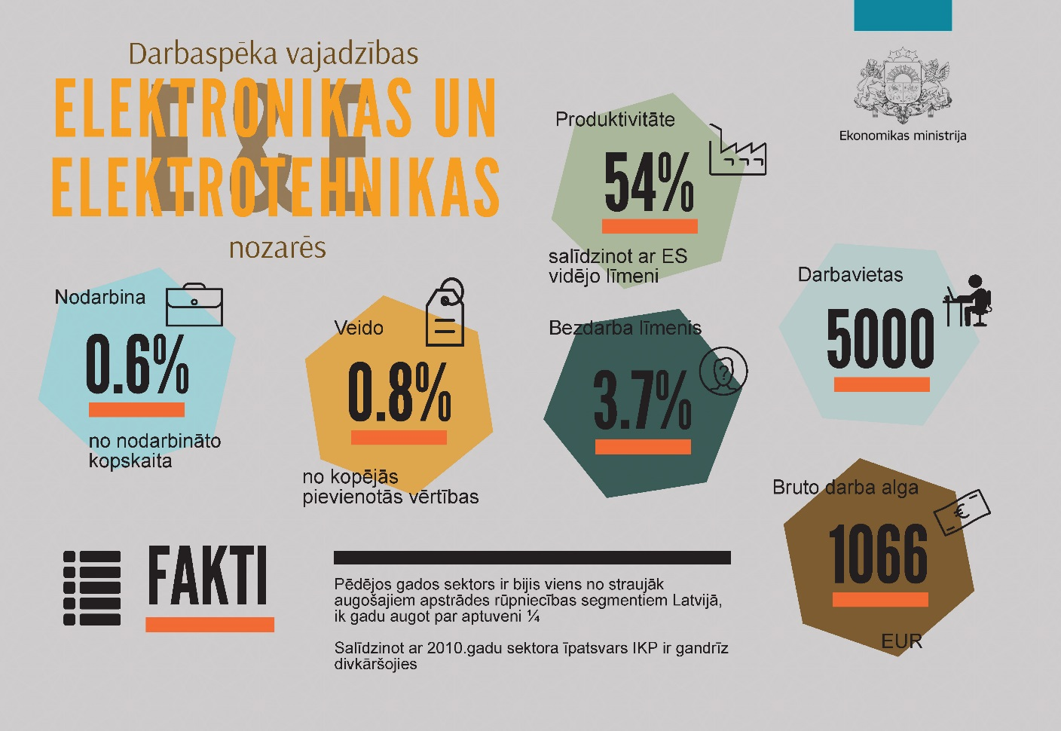

Labour Force Demand – Changes and Structure
In 2017, more than 5 thousand people, or 0.6% of employed, were working in E&E (electronic and electrical engineering) sector. Since 2010, the number of employed in E&E has increased by more than 1,700. The increase can mainly be attributed to the growing demand for labour in such sub-sectors as the manufacture of wiring and wiring devices and the manufacture of electronic components and boards.
Number of Employed in E&E (Electronic and Electrical Engineering)
changes
 | 2010 | 2017f | changes
MANUFACTURE OF COMPUTER, ELECTRONIC, AND OPTICAL PRODUCTS | 1240 | 2016 | 776
Manufacture of electronic components and boards | 365 | 816 | 451
Manufacture of computers and peripheral equipment | 72 | 85 | 13
Manufacture of communication equipment | 324 | 453 | 129
Manufacture of consumer electronics | 77 | 103 | 26
Manufacture of instruments and appliances for measuring, testing and navigation; watches and clocks | 326 | 469 | 143
Manufacture of irradiation, electromedical and electrotherapeutic equipment | 2 | 9 | 7
Manufacture of optical instruments and photographic equipment | 75 | 81 | 6
MANUFACTURE OF ELECTRICAL EQUIPMENT | 2131 | 3076 | 945
Manufacture of electric motors, generators, transformers and electricity distribution and control apparatus | 1245 | 1328 | 83
Manufacture of batteries and accumulators | 1 | 2 | 1
Manufacture of wiring and wiring devices | 716 | 1398 | 682
Manufacture of electric lighting equipment | 85 | 186 | 101
Manufacture of domestic appliances | 18 | 41 | 23
Manufacture of other electrical equipment | 66 | 121 | 55
TOTAL: | 3371 | 5092 | 1721
Source: CSB; f – forecast by the Ministry of Economics

Number of Employed in E&E
in thousands
Source: CSB; f – forecast by the Ministry of Economics

Structure of Labour Force Demand in E&E
2015, %

Source: State Revenue Service (SRS), CSB, calculations by the Ministry of Economics

Over the last seven years, an almost equally rapid increase in labour demand in both the manufacture of electronic and electrical equipment can be observed. However, given the sector-specific intensity of knowledge and the complexity of production, each sector is characterized by a different structure of labour demand.
Manufacture of computer, electronic, and optical products is generally characterized by knowledge intensive activities, and approximately 57% (by 15pp higher than the average in the economy) of workplaces in the sector require higher qualification.
A slightly different situation in the manufacture of electrical equipment can be observed – 63% of employees work in medium qualification occupations.

Sufficiency of Labour Force in E&E
In August 2018, the registered unemployment rate in E&E was 3.7% (almost half the national average). At the same time, the average gross wage in E&E for a full-time job reached EUR 1315 (by 17% higher than the average in Latvia).
The low unemployment rate and the higher remuneration in the sector point to the prevalence of labour demand over supply.
Insufficiency of labour force can be observed among the electrical engineers, electrical engineering technicians, and electronics mechanics and servicers.
In August 2018, the unemployment rate in all the above-mentioned occupations was below the national average, and the gross wage exceeded the average gross wage of the corresponding occupational group.
Normalized Monthly Gross Wage in E&E Occupations*
June 2018, EUR

* Expressed in a full-time equivalent
Source: State Revenue Service of Latvia (SRS), calculations by the Ministry of Economics

\
Registered Unemployment and Average Gross Wage in E&E
End of July 2018 (SEA), June 2018 (SRS)

Source: State Employment Agency of Latvia (SEA), State Revenue Service of Latvia (SRS), CSB, the Ministry of Economics

At the end of July 2018, 134 vacancies and 239 job seekers in E&E occupations in the State Employment Agency (SEA) were registered.
The largest number of vacancies was registered among the electrical and electronic equipment assemblers, which almost by three times exceeds the number of registered job seekers with previous experience within the field. The second largest number of vacancies, however, was registered among the electronics engineering technicians.
Although the number of job seekers exceeds the number of vacancies in E&E occupations, the decline of the job vacancy rate is hampered by regional labour market imbalances. Almost 80% of job vacancies are located in Riga region; however, a large part of job seekers lives outside Riga agglomeration.

Overall, E&E occupations are not exposed to the risk of labour shortages due to high replacement demand for labour.
Approximately 57% of employees in E&E occupations are under 44 years of age;
thus, no signs of ageing of the workforce have been observed.
The highest average age of the employed is observed in senior specialist E&E occupations, where approximately 53% of employees are over the age of 44.

Age Structure of Employees in E&E
2017

Source: CSB, calculations by the Ministry of Economics

Registered Unemployed and Job Vacancies in E&E Occupations
End of July 2018

Source: State Employment Agency of Latvia (SEA)

Labour Force Demand and Supply Forecasts

In the medium- and long-term, the growth of the E&E sector will mainly be based on the increase in productivity. Thus, the growth of the labour demand will remain moderate – by 2035 the number of workplaces could increase by 1.9 thousand.
The largest growth in workplaces in E&E is expected in the manufacture of electronic components and boards, the manufacture of wiring and wiring devices, and the manufacture of communication equipment.
It should be taken into consideration that in the electronics and electrical engineering sector, it is especially difficult for Latvia to compete with labour-intensive countries, such as China and India. Thus, the development trends of the E&E sector will mainly be determined by a strong specialization and orientation towards high value-added niche products with low labour capacity.
Changes in the Labour Force Demand in E&E
2017

Source: forecast by the Ministry of Economics

Changes in the Labour Force Demand in E&E Occupations
thousands

Source: forecast by the Ministry of Economics

Almost half of the total growth in the number of workplaces in E&E could occur in specialized E&E occupations,
mainly among the electrical engineers, electrical engineering technicians, and electronics engineering technicians.
At the same time, demand for E&E sector specialists in the economy could increase by approximately 3 thousand by 2035, in comparison to 2017.

Along with an increased demand in certain E&E occupations, the supply of relevant specialists in the future will increase. However, taking into consideration the current training intensity of specialists, the future education system most likely will not be able to compensate labour force demand in all E&E occupations.
In the medium-term, labour force shortages will remain among electrical engineers, electronics engineering technicians, and electronics mechanics and servicers.
Ratio of Labour Force Demand and Supply in E&E Occupations
2025 (%), supply=100

Source: forecast by the Ministry of Economics

SUMMARY

More than 5 thousand people, or 0.6% of employed in the economy, are working in E&E.

Since 2010, the number of employed in E&E has increased by 1.5 times – by more than 1,700 employees (almost 2/3 of them were employed in the manufacture of wiring and wiring devices and the manufacture of electronic components and boards).

The registered unemployment rate in E&E occupations is almost half the national average. Insufficiency of labour force can be observed among the electrical engineers, electrical engineering technicians, and electronics mechanics and servicers.

By 2035 the number of workplaces in E&E could increase by 1.9 thousand. The largest growth in the number of workplaces in E&E is expected in the manufacture of electronic components and boards, the manufacture of wiring and wiring devices, and the manufacture of communication equipment. Almost half of the total growth in the number of workplaces in E&E could occur in specialized E&E occupations.

In the medium-term, labour force shortages will remain among electrical engineers, electronics engineering technicians, and electronics mechanics and servicers.

ANNEX

Electronic and Electrical Engineering (E&E) Sector
NACE 2 code | Sector and sub-sectors
 | Manufacture of computer, electronic and optical products
C261 | Manufacture of electronic components and boards
C262 | Manufacture of computers and peripheral equipment
C263 | Manufacture of communication equipment
C264 | Manufacture of consumer electronics
C265 | Manufacture of instruments and appliances for measuring, testing and navigation; watches and clocks
C266 | Manufacture of irradiation, electromedical and electrotherapeutic equipment
C267 | Manufacture of optical instruments and photographic equipment
C268 | Manufacture of magnetic and optical media
 | Manufacture of electrical equipment
C271 | Manufacture of electric motors, generators, transformers and electricity distribution and control apparatus
C272 | Manufacture of batteries and accumulators
C273 | Manufacture of wiring and wiring devices
C274 | Manufacture of electric lighting equipment
C275 | Manufacture of domestic appliances
C279 | Manufacture of other electrical equipment

Occupations in Electronic and Electrical Engineering
ISCO-08 code | Occupational groups and sub-groups
2 | Professionals
2151 | Electrical engineers
2152 | Electronics engineers
3 | Technicians and associate professionals
3113 | Electrical engineering technicians
3114 | Electronics engineering technicians
7-8 | Electrical equipment installers, repairers, and assemblers
7421 | Electronics mechanics and servicers
8212 | Electrical and electronic equipment assemblers

Electronic and Electrical Engineering Thematic Groups of Education
ISCED2011 code | Sphere of education
522 | Energy
523 | Electronics and automation

Number of Employed in ICT and E&E Sectors
 | Fact |  |  | Estimate
 | 2006 | 2010 | 2016 | 2017 | 2025 | 2035
Manufacture of computer, electronic and optical products | 1968 | 1240 | 1899 | 2016 | 2463 | 3176
Manufacture of instruments and appliances for measuring, testing and navigation; watches and clocks | 367 | 365 | 759 | 816 | 1130 | 1685
Manufacture of irradiation, electromedical and electrotherapeutic equipment | 49 | 72 | 76 | 85 | 100 | 119
Manufacture of optical instruments and photographic equipment | 523 | 324 | 435 | 453 | 538 | 645
Manufacture of electronic components and boards | 272 | 77 | 104 | 103 | 135 | 186
Manufacture of computers and peripheral equipment | 672 | 326 | 441 | 469 | 492 | 493
Manufacture of communication equipment | 14 | 2 | 4 | 9 | 11 | 15
Manufacture of consumer electronics | 71 | 75 | 80 | 81 | 57 | 33
Manufacture of electrical equipment | 3149 | 2131 | 2817 | 3076 | 3403 | 3809
Manufacture of electric motors, generators, transformers and electricity distribution and control apparatus | 1651 | 1245 | 1315 | 1328 | 1352 | 1323
Manufacture of batteries and accumulators | 17 | 1 | 2 | 2 | 1 | 0
Manufacture of wiring and wiring devices | 1070 | 716 | 1191 | 1398 | 1673 | 2062
Manufacture of electric lighting equipment | 279 | 85 | 145 | 186 | 232 | 304
Manufacture of domestic appliances | 30 | 18 | 38 | 41 | 42 | 41
Manufacture of other electrical equipment | 102 | 66 | 126 | 121 | 103 | 79
Total: | 5117 | 3371 | 4716 | 5092 | 5866 | 6985

Ratio of Labour Force Demand and Supply in E&E Occupations
 | Demand,  thousands |  | Supply,  thousands |  | Demand vs. Supply  (“-” shortage)
 | 2025 | 2035 | 2025 | 2035 | 2025 | 2035
Professionals | 2016 | 2430 | 1830 | 1988 | -186 | -442
Electrical engineers | 1318 | 1636 | 1072 | 1157 | -246 | -479
Electronics engineers | 698 | 794 | 758 | 831 | 60 | 37
Technicians and associate professionals | 2982 | 3888 | 2976 | 3960 | -6 | 72
Electrical engineering technicians | 1763 | 2299 | 1718 | 2228 | -45 | -71
Electronics engineering technicians | 1219 | 1589 | 1258 | 1732 | 39 | 143
Electrical equipment installers, repairers, and assemblers | 1563 | 1794 | 1643 | 1907 | 80 | 113
Electronics mechanics and servicers | 569 | 627 | 524 | 586 | -45 | -41
Electrical and electronic equipment assemblers | 994 | 1167 | 1119 | 1321 | 125 | 154
Total: | 6561 | 8112 | 6449 | 7855 | -112 | -257

Age Structure of Employees in E&E
Professionals Technicians and associate professionals Electrical equipment installers, repairers, and assemblers

